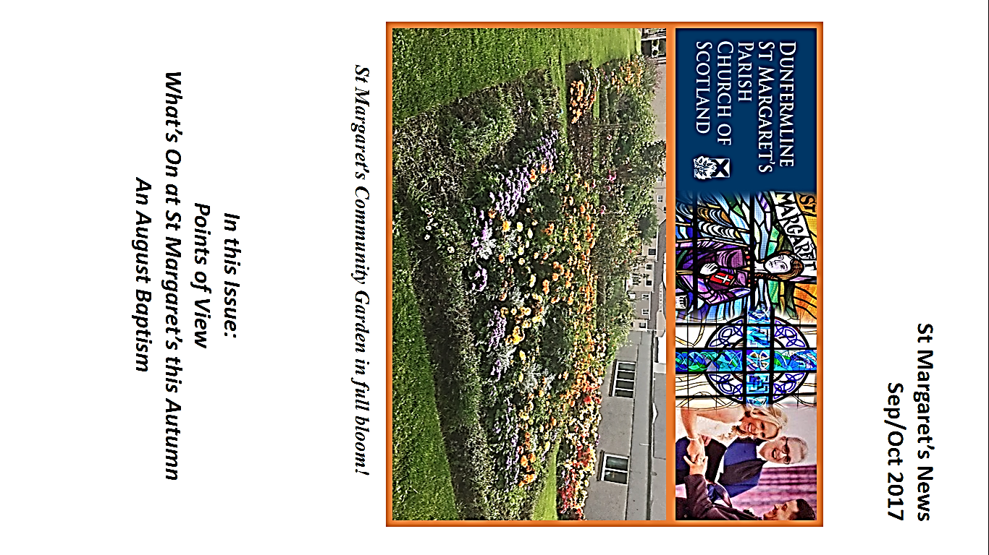

**Contents**

**From the Minister:” It’s only a building!” p3-p4**

**From the Editor p5-p6**

**Communion p7**

**From our Reader: Prepare for Christmas SPIRITUALLY p8**

**Leading Worship p9**

**An August Baptism! P10**

**Thank You Page p11**

**Points of View p12-p14**

**J.A.M. Report p15**

**Scouts and Beavers p16-p18**

**Etta’s Mission and Charities News p19-p23**

**St Margaret’s Church Finance Report p24-p25**

**Dates for your Diary p26-p30**

**Organisations p31**

**St Margaret’s Church Contacts p32**

**From the Minister:**

**“It’s Only a Building!”**

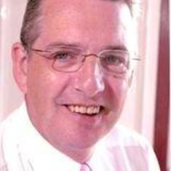On the one hand St. Margaret’s Sanctuary and halls is only a suite of halls – a building! But it is surely more than that!

It is the place where we worship – where we are instructed, inspired, find faith. We also have a Bible Study Group and regular special study seasons.

It is a place of fellowship – where we get to know people and establish life-long friendships.

It is a place of activities – JAM meets there and young people are taught and encouraged to follow Jesus. They also have fun and develop strong relationships with one another and with the leaders.

We have a community café for members of the church community and the local community. We have a Credit Union too!

There is a vital support group in the church and also Swingnastics, Badminton, Monday Evening Bowls and other activity groups.

We have Church groups – Guild, Woman’s Fellowship, Men’s Breakfast Fellowship, Craft Group.

On a Monday night we have a Family Group from the local community.

Guides, Brownies and Rainbows meet in the Church.

We have an open-door policy to any community group wishing to set up in our building.

The Church is not a building but the building we have allows us to have imaginative and supportive organisations.

I indicated that the cost of refurbishments to church and manse were going to cost £220,000. We have a responsibility to care for our buildings and once in a generation most churches have to face a major fundraise like our own.

Let me lay out the financial situation so far:

Actual donations £66,000

From Existing Funds £44,000

Grants Promised £16,000

Potential Grants £45,000

Fundraisers to Summer 2018 £15,000

Total £186,000

This means at this point we are £34,000 short of our total. I am therefore asking each and every member to try and be as generous as possible in giving towards this final fund in order for us to avoid having to take out a loan [though the Church of Scotland has offered us up to £60,000 at 5% 0ver the next 5 years]. Will you please think seriously about making any size of donation to enable us to reach our target?

At the beginning of 2016 we were offered a grant of £27000 towards employing a part-time Family and Children’s worker. For various reasons on two separate occasions we came near to getting someone but both times it failed to materialise. We were told last week that the funding would be pulled unless we found someone within 6 weeks. Our son, Alistair has just concluded a degree in psychology and has applied for the position. He was interviewed and offered to job by the Kirk Session and so will begin working in post from 1st September – please pray for him and all who will support him in this new post for St. Margaret’s.

God Bless you all.

**Iain**

**FROM THE EDITOR**

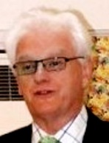**Hello – and welcome back to the magazine after a short summer break! Yes –that was our summer and if you are anything like me I have to admit to being somewhat disappointed with the seldom appearance of the sun!!! However – compared to some we were lucky! We did not have forest fires, we did not have a heat wave that took lives of some, we did not have mud slides that took more lives and although some of the country had a lot of rain we did not have the severe floods that shook other parts of the UK or elsewhere in the world. So let’s be thankful!**

**We have now collated the names of those people who want to use the website to obtain the magazine – more of that elsewhere in the magazine. You will note the letter from the minister which includes roof funding information – well I thought it was worth pointing out that the afternoon teas that were arranged brought in just over £1,000 – absolutely FANTASTIC. There was a huge amount of work went into the preparation of these afternoons with donations of baking etc being handed in and of course a great deal of setting up the room and everything else that is not seen. HUGE thanks to the people involved in all this – GREAT job well done and what a super amount of cash to go toward the roof. A BIG thank you too to those of you who came along to enjoy the feast. You see how your £7 helped to build up to that total £1,000 that was raised – superb support from you – and of course this gives encouragement to those that have done all the work.**

**You will note that I have now included a new item to the magazine – POINTS OF VIEW – and you will read the two contributions that I have had for this edition. I would really encourage you to PLEASE take part in this. As indicated you can either identify yourself or put something in anonymously ( as long as you give name & address to me please – those details will not be printed). Your opinions, views, appreciations and general offerings will be very welcome. The two contributions I have received this month are a great example. Just to advise that as from January 2018 the magazine will be printed once a quarter but I will have information on date of “contributions required by” in the order of service in plenty of time. Thanks too to those that attend the gardens and who give us the colourful display as shown on the front cover this time – well done folks! Anyone who knows who pinched the Church notice at the garden please get in touch!!!!!**

**Hope you enjoy the read - and remember:**

**YOU ARE NOT ALONE!**

**Ross Kerr**

**CHURCH MAGAZINE DISTRIBUTION AND ACCESS THROUGH THE WEB SITE**.

As you will be aware we have been looking at how to offer the Church Magazine on line through the church website. Distributors have been collating those names of people who would prefer to access the magazine through the website and I am now ready to start this process.

Those who are going to go through the website will receive this copy as before – ie on paper. This is to alert you to the fact that future magazines will NOT be delivered to you. Just to remind you of the process of finding it on the website I am repeating what Morna produced some months ago, as follows:

Go to the Dunfermline St. Margaret’s website and click on “magazine” from the menu at the top of the page. Click on the edition you want to read. Scroll down through the pages using your mouse or scroll down the arrow keys. The church website can be found at:

[www.stmargscos.org.uk](http://www.stmargscos.org.uk)

This means that the first edition of the magazine that will NOT be delivered to you will be for November/December.

Everyone else will continue to receive their paper copy of the magazine as usual.

Please all do continue to enjoy the magazine and feel free to send me in comments with both thoughts and contributions.

Thanks

Ross Kerr

Editor



**THE KIRK SESSION WARMLY INVITES YOU TO COMMUNION on**

**Sunday 17th September, 2017**

**Morning Communion 10am**

**Evening Communion 7.30pm**

**We look forward very much indeed to welcoming you to either or both Services**

**COMMUNION DUTY**

|  |  |
| --- | --- |
| **SEPTEMBER 17th**  Session Clerk: Mrs. Irene Cunningham  Senior Elder: Millar Gordon   1. J Colville 2. J Adamson 3. Mrs. L Adamson 4. J Anderson 5. S Foxley 6. I Telfer 7. Mrs. E Pratt 8. Mrs. A Prentice   Reserve: Mrs. S Richards | **NOVEMBER 19th**  Session Clerk: Ritchie Campbell  Senior Elder: Ross Kerr   1. Mrs. I Cunningham 2. Mrs. I Gillespie 3. Mrs. J McAleece 4. Mrs. J Gresty 5. J Thomson 6. M Giraldas 7. D Clark 8. Mrs J Eadie   Reserve: Mrs. M Watson |

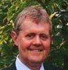

**From our Reader**

*Prepare for Christmas* **SPIRITUALLY**

It has started already. Mid-August and I saw the first advertisements for “Christmas lunches”; then soon after, the first “Christmas decorations” in certain shops that will remain nameless. Over the coming weeks the commercial activity around Christmas will steadily increase until it turns into the usual frenzy.

So we too want to get in on the act early – but from a spiritual perspective.

We invite you now to make a note in your diaries or calendar – **of two (maybe three)** **midweek, evening, services in November**.

What Beethoven is to music and Shakespeare is to literature, Isaiah is to prophecy. So at these hour long services we will take a look at **Isaiah, the man and the book, and what he has to say about the coming Messiah**. Hundreds of years beforehand – in colourful language and powerful imagery – Isaiah lays the tracks for the coming of Jesus.

Hopefully these simple and informal acts of worship will begin to prepare us for the real Christmas season.

I really hope you will find time to join us. Watch out for further details shortly.

**Gordon Brown**

**‘Leading Worship’ – Readings – Information Sessions**

**Saturday 21st and Saturday, 28th October, 2017**

If you would like to take part in a Sunday Service by reading selected verses from the Bible, then please read on and even if you don’t, have a look and see what you are missing!

Two **Information Sessions** are being organised to take place in the Church Upper Hall on:

**Saturday, 21st October, 2017: 10.00am-12 noon and**

**Saturday 28th October, 2017: 10.00am-2pm**

Gordon Brown has been in touch with Ishbel Smith, who lectures at New College in Edinburgh and delivers various kinds of sessions on behalf of the Church of Scotland. Ishbel will be coming along to give guidance and the sessions will run in an informative but light-hearted approach.

At the first session, Ishbel will describe and give advice on presentation and delivery.

At the end of the first session you will be invited to select a reading, poem or prayer etc to “present” at the second session when there will be 4 sessions of one hour. Fellow members of the groups and Ishbel will critique each short presentation.

Please be in touch with Gordon Brown or (Marjory McIntosh, 01383 726342) if you would like to be included.

**On behalf of the Christian Education and Worship (CEW) Committee**

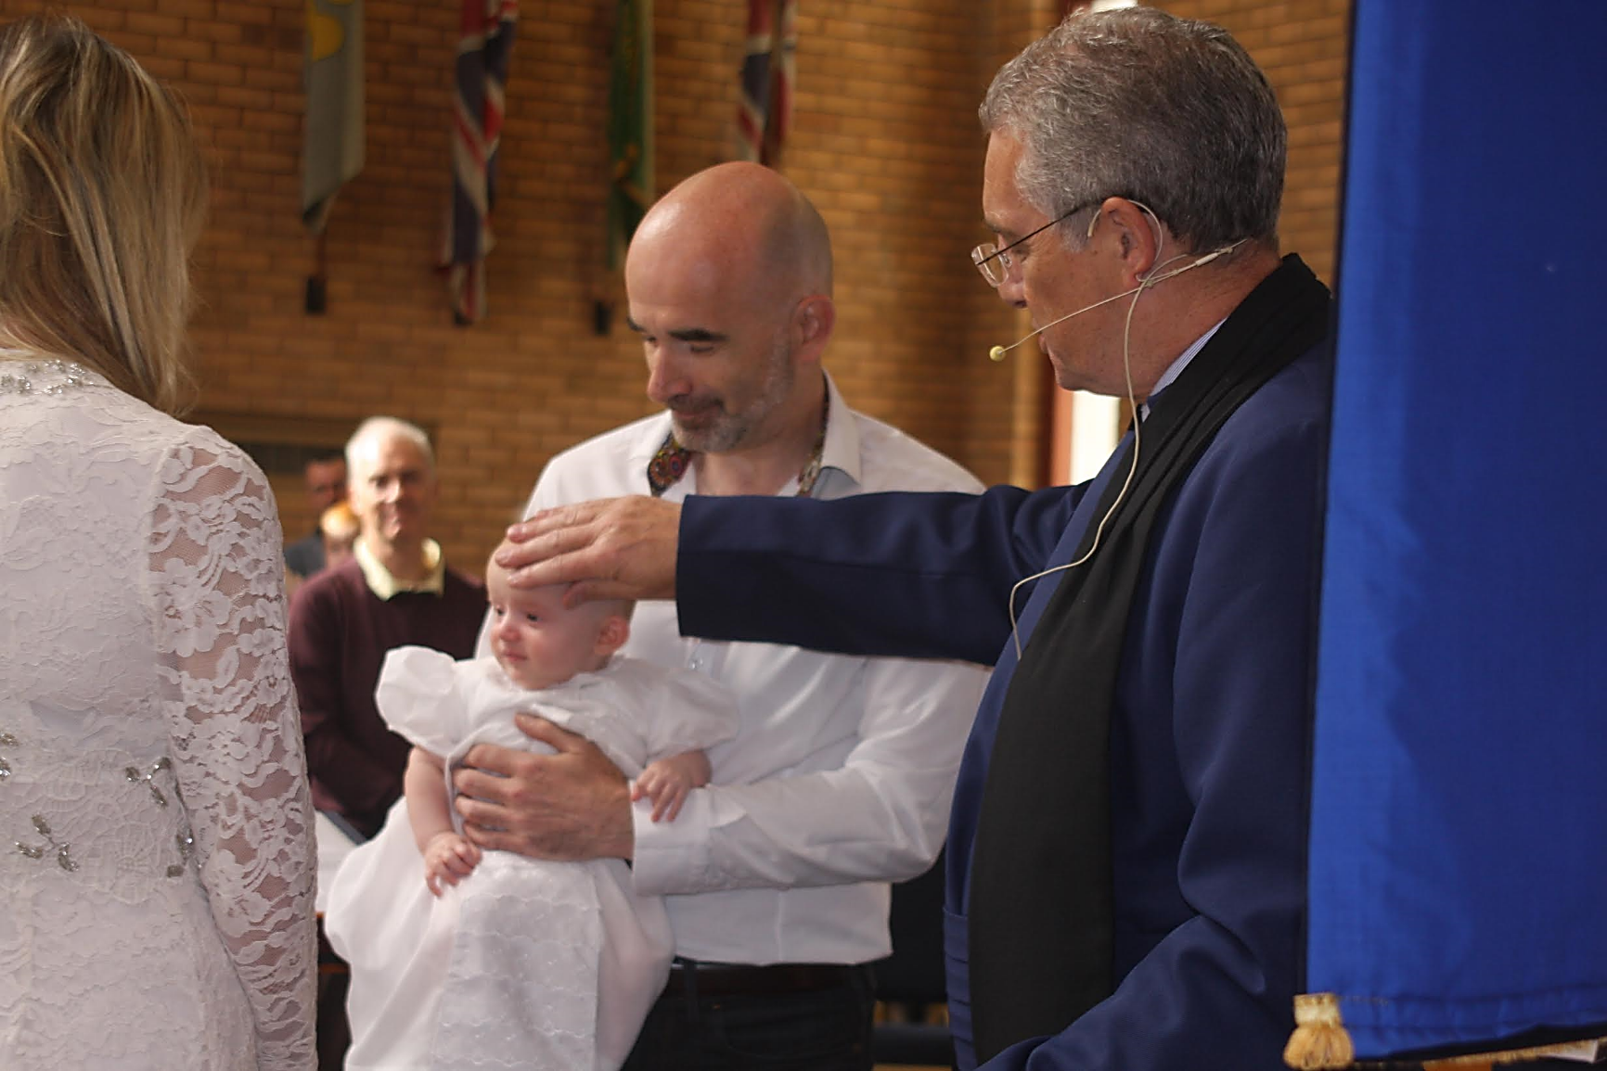

**Baptism of Daniel Ross Kerr on 27th August, 2017, at St. Margaret’s Parish Church, Dunfermline.**

**Many thanks to the Rev. Iain Greenshields for conducting such a wonderful service and to the congregation of St. Margaret’s for the very warm welcome they gave to all in the Baptism party**

**THANK YOU PAGE**

**A BIG thank you to all who sent me cards and best wishes on my move to Edinburgh, after my long association in St. Margaret’s. Wishing you all success in the future.**

**Margaret Ellis**

***(Thanks Margaret – we all hope that you have settled in well. Best wishes from us all - Ed)***

**THANK YOU**

**I would like to thank everyone at St. Margaret’s for their very warm welcome to all of us that were involved with the Baptism of my son Daniel Ross Kerr on Sunday 27th August, 2017. We were all made to feel very welcome – not that I would expect anything different from the St. Margaret’s people! Rebecca’s parents and siblings were appreciative of the friendship shown to them and felt the service was wonderful – as did we all.**

**I would also like to thank the Rev. Iain Greenshields for his guidance, advice and the delivery of the actual Baptism itself which again was a wonderful experience for all of us. And I think that Gordon has created a new career for himself in the entertaining business (unfortunately this will be lost on those that were not present but it is worth watching on the screening of the service!!)**

**It was good to be “home” for this service and good to meet so many of you from my days at St. Margaret’s and a very big Thanks You from Rebecca and myself for the cards and gifts we received.**

**Best wishes**

**Duncan Kerr**

**https://mail.google.com/mail/u/0/images/cleardot.gif**

**Points of View**

**This is a new feature for the magazine. Anyone who has a “point of view” that is relevant should send it in to me to put in the magazine. We have two examples this month – one where it is anonymous but name and address supplied, the other which has given their name. I know that some people prefer to be anonymous and that is fine –( I will however screen what is sent in!!!! ) I hope you like this new concept for the magazine and I do look forward to receiving items for each edition of the magazine. Enjoy! (Ed)**

**Depends on how**

**you tell it**

**A Church of Scotland report prepared before the 2015 General Assembly reported that membership had fallen by more than 155,000in the previous decade and that in 2014 alone had declined by 16,000, the equivalent of 300 members per week.**

**The Blue Book which was issued for this year’s General Assembly advises that Church membership is again down by 16,000 to a figure of 380,000and offers a picture of the Church in “serious decline”**

**Other surveys refer to a “Church in dramatic decline”**

**In contrast to the foregoing I was struck by the recent sermon given by Gordon in which he made reference to the fact that starting with the twelve disciples in a period of just over 2,000 years there are now over 2.3 billion Christians, an annual growth of just under 1% year on year.**

**Even after recognising that we are not comparing like with like which statistic do you find more attractive and which portrays the more positive message?**

**It really does depend on how you tell it.**

**A M**

**(Name and address supplied)**

**https://mail.google.com/mail/u/0/images/cleardot.gif**

**GREYFRIAR’S**

**Gordon’s Thoughts**

**When on holiday, Helen and I like to experience worship in other churches. One of those we visited this summer was – Greyfriar’s in Edinburgh. It sits tucked away at the south end of George IV Bridge, behind the statue of the little dog, Greyfriar’s Bobby and the pub bearing the same name.**

**It is a beautiful church with excellent acoustics which is why it is such a popular venue for musical events. The evening before we visited, the National Youth Orchestra had played to a ‘full house’ of 500. The chancel area and pulpit are unusually located in the centre of the building, with a 20 strong robed choir on one side and the congregation on the other. The magnificent church organ is a recent acquisition.**

**The style of worship was traditional with - a call to gather, a collect, affirmation of faith, Old and New Testament readings, anthem, sermon (about what’s in a name, based on the story of Jacob and Esau) and prayers.**

**Despite there being only about 70 in the congregation (for the main weekly act of worship) the church is fortunate to have a Minister and Associate Minister and, on the day we were there, a Probationer, who preached. I was particularly interested in the liturgy and order of worship. I found the ‘affirmation of faith’, said together, especially uplifting. I would like to share it with you at one of our Sunday mornings. All in all, a good experience.**

**GREYFRIAR’S**

**Helen’s thoughts**

**Greyfriars was a beautiful building with a pleasant uncluttered and airy feel to it, lending itself perfectly for music and song from a magnificent organ. We were**

**made to feel most welcome particularly by one gentleman and offered an order of service to share.**

**It struck me that churches have many different approaches to this. St Margaret’s providing service details and intimations also announced by the minister; Greyfriars a shared leaflet including intimations, and Charlotte Baptist Chapel, which we also visited, a leaflet simply giving the readings for the day and intimations but no order of service.**

**The other thing that struck me was at Greyfriars the minister gave the reading with no visual aid and no-one used the pew bible. At St Margaret’s we enjoy the benefit of a screen and an oratory whereas at Charlotte nearly everyone followed the reading on their cell phone or tablet.**

**Different churches have different traditions of course and that extends to the different style of dress adopted by the ministers. Iain alternates between robes and suit, Greyfriars are always robed and Charlotte are completely casual with the minister usually shirt sleeves and chinos!**

**It’s good to experience “different” styles of worship and perhaps adopt some new methods ourselves where appropriate.**

**I suppose the over-riding feeling for me is the very fact that we are all of the same family in Jesus and however our worship is orchestrated it comes from the heart.**

**Helen & Gordon Brown**

J.A.M. Club

We are now looking forward to our eighth year of J.A.M. Club! Hopefully, everyone has enjoyed a lovely break during the holidays and our “batteries have been re-charged!”

This is a time when many new things happen in the lives of the boys and girls who attend our club each week. Some have made the transition from primary to secondary school.....a huge step for them! Others have moved from a familiar class to the next stage in primary school, again new experiences are involved. With this busy time in mind, I decided that our first theme in our new session could be introduced by thinking about FIDGET SPINNERS!

(For those of you who perhaps don’t even know what a fidget spinner is......it’s a gadget which is very popular just now with the majority of young people. Please see the picture below. You can control a fidget spinner, allowing it to spin fast....or slow it down.)

For many of us, life at times seems to go too fast (it spins out of our control) and we struggle to cope with the ever-increasing pace. We can’t make things slow down enough for us to adequately manage all that is expected of us.......this sums up how many children feel at the moment.

**Life cannot be controlled like a fidget spinner!**

However, we can get help.....if we present our worries to Jesus, we will always be given what we need. He can help us regain order in our lives and get things back “under control.”

So, this is the first (and most important message) which we will be giving the boys and girls as we begin our new session. I hope you will agree it’s very appropriate.

May I ask you to continue to remember our J.A.M. Club children and their families in your prayers. Thank you.

**[](http://www.instructables.com/id/Fidget-Toy-Hand-Spinner/?ALLSTEPS)**

Love and blessings

from

Linda (on behalf of everyone at J.A.M. Club)

# MACKENZIE MOMENTS

**By Yolanda Pearson**

What a busy start to the year!

we cannot make Beavers, so it is important we keep our parent rota filled up. Thank you to the parents who have helped so far and if your name is not up, please do consider it.

**ACTIVITIES ….**

We have been learning about the Green Cross Code and how to cross a road safely. The Beavers had also been learning about this at school and knew what to do and how to keep themselves safe.

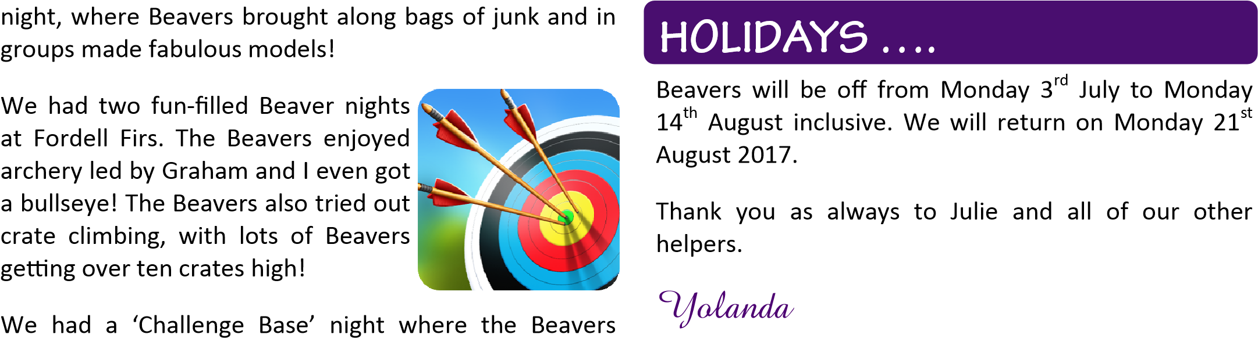Sophie one of our young Leaders led a junk modelling

decorated biscuits at one base, at another base they learned to roll / fold their neckies and at the final base they were shown how to light a candle safely! Another night we planted cress seeds for the Beavers to take home, grow and eat! We hope they remembered to water them! 

Several Beavers enjoyed taking part in our Family Camp with their parents. It was a great weekend where parents learned valuable lessons on why we ask for waterproof jackets, trousers, and sturdy footwear!!

Sophie, our young Leader, again led a night, where she talked to the Beavers about Diwali and they coloured prayer mats.

CHAL**LENGES…**

We have been thinking about our ‘Personal Challenges’ and each Beaver wrote down their own personal challenges. Some wrote down as many as ten when they were only asked for two! They were far ranging from, less screen time or Lego time, to not chatting in class at school!

For our ‘Teamwork Challenge’ the Beavers were split into groups and each group was given a bag of dried spaghetti and two bags of marshmallows! The challenge was to build the tallest self-standing tower! The Beavers concentrated hard to make the towers stand and some impressive structures were built!

## 

**Etta’s Charities and World Mission News**

**DUNFERMLINE FOODBANK UPDATE**

Thank you once again for all the contributions to the foodbank, the Team are grateful for all donations. There is now a blue box on the top landing next to the Rita Elder Hall for contributions.

**USED STAMPS -** ongoing collection

Thanks for all the donations of used stamps, they are normally recycled by Kinross stamp shop to raise funds for the CHAS charity. However a large bag has also been taken to the Presbytery office in Glasgow during the summer for the World Mission Stamp Appeal 2017.

These stamps are to be sold to make money for much needed resources for the Giffen Institute of Theology (GIT) of the Presbyterian Church of South Sedan (PCOSS). GIT was established in 1974 by the PCOSS and it plays a significant role in training people for ministry. South Sudan has suffered terrible violence and war in recent years and GIT has been force to relocate twice, resources, including books, were lost or destroyed during this time. The stamp appeal will help to stock up its library for the students.

**SEGAL HOMELESS HOSTEL -** Pittencrief Street, Dunfermline

Many thanks for the donations of clothes and childrens play sacks which were handed in to the homeless unit, they were very much appreciated.

Segal Hostel is a family hostel and can have up to 24 people in at any one time, often families come in through the night in emergency situations and only have the clothes they stand up in. Donations such as:

Toiletries; clothing, adults and children (new only); toys (new only), and food donations are always in demand.

Please contact me if you feel you can contribute to the hostel or items can be handed in to the hostel at the reception desk. Thank you

Etta Pratt

**CHRISTIAN AID WEEK 2017**

Thanks very much to everyone who helped raise the sum of £361 at the church coffee morning on 14th May. A letter was received from Christian Aid thanking the congregation for their support.

**THE LEPROSY MISSION SCOTLAND**

The Leprosy Mission has sent out copies of their Dochas, Gaelic for ‘Hope’, magazine, relating stories of their work throughout the world. They are on the shelf just outside the Rita Elder hall for anyone who is interested.

**NEWS SNIPPETS FROM THE WORLD MISSION COUNCIL**

**MAGAZINE ISSUE NO 79**

Contributors: Julie Griffiths, Church Family and Schools Worker

Alloway Parish.

Eva Domínguez Sosa Iglesia Evangelica Espanola (Spanish Evangelical Church).

Douglas Simpson Church of Scotland Member.

Lorna Tunstall World Mission Council.

This issue include articles on the following:

**Chickens Away!** Ayr Presbytery’s Visit to Malawi

Julie Griffiths shares her thoughts from a recent visit to Malawi with Ayr

Presbytery

*In Malawi people are what matter. Community is everything.*

*‘I recently had the privilege of leading a team from Ayr Presbytery to Malawi, the ‘warm heart of Africa’. We visited 37 partner projects including hospitals, youth diversion projects, an HIV project, churches, schools and nurseries, and*

*widows associations. We placed wreaths on the graves of the first Scottish Missionaries. At many projects we were treated to Malawian singing and dancing. Every place is filled with joy and celebration.’*

***Read more of this article in the magazine****.*

**No One Is Left Behind**. HIV: The Home Based Care and Support Project in Nigeria

*The Church of Scotland HIV Programme supports people living with and affected by HIV (PLWH), it raises awareness of the virus, and it challenges the stigma people living with HIV might face.*

*Read how the Rev. Okechukwu Kalu Iro runs a Home Based Care and Support project for people living with HIV in Abia State, Nigeria. This project*

*is supported by the Church of Scotland HIV Programme, and is part of the Presbyterian Church of Nigeria.*

**Created by Refugees**. A series of Images created by refugees from Mediterranean Hope

*Mediterranean Hope is a project of the Federation of Evangelical Churches in Italy, and is supported by the Waldesian Church, our partner in Italy.*

*Mediterranean Hope offers refugees and asylum seekers the opportunity to be flown directly to Italy without having to risk the dangerous conditions of travelling over land and sea. Once in Italy, practical, social and emotional help is at hand. These images created by refugees working with the project are a powerful representation of the situations refugees and asylum seekers face today.*

For more information visit: [www.SFAR.org.uk](http://www.SFAR.org.uk)

**Prayer Focus**. Where Two or Three Are Gathered

*Father, we pray for your church*

*throughout the world.*

*A church that always seeks new ways*

*of making the gospel known,*

*revealing you to men and women*

*everywhere,*

*and reconciling them to you and to*

*one another.*

*with a renewed sense of being one in*

*Christ.*

*Father, we pray for a church that*

*thrives in diversity,*

*for a deeper sense of our belonging*

*together and to each other*

*regardless of our different hopes,*

*fears, visions and dreams.*

*Help us to discover a new joy in being*

*the people of God,*

*and give us a fresh delight in each*

*other’s fellowship, worship and praise.*

*Father, we pray that Christians*

*everywhere may love their neighbours*

*as you love and cherish us for whom*

*we are.*

*Give us a new ability to stamp out any*

*prejudiced positions,*

*and to break down the walls that*

*divide.*

*And may the grace and love of Christ*

*bind us to stand together as one,*

*forever.*

*Amen*

**A Trip to the Holy Land: A Place of Vivid Contrast**. Learning from People and Partners in Palestine and Israel

*Douglas Simpson visited Palestine and Israel on a trip organised by the World*

*Mission Council.*

**Journeying to Justice**. Eva Domínguez Sosa’s Turbulent Journey to Ministry

*Originally from Tabasco in Mexico now a Pastor in Spain she shares her journey to being ordained.*

**Women in the World Churc**h. Conference

**16 September 2017 from 10.30am – 3.30pm**

**Martin Hall, New College, Edinburgh**

Keynote Speaker, Professor Kwok Pui Lan, an influential feminist theologian who is giving this year’s Duff Missionary Lecture.

Other speakers include: Rev Rola Sleiman from Lebanon, Rev Nosheen Khan from Pakistan, Dr Isobel Phiri from the World Council of Churches, and Nuam Hutzaw, a student from the University of Edinburgh.

If you want to read more of these stories please see the current World Mission magazine which can be downloaded from [www.churchofscotland.org.uk](http://www.churchofscotland.org.uk) or I can supply you with a paper copy.

**Etta Pratt**

***(Copyright 2013 World Mission Council, Church of Scotland.  All rights reserved. Permission is granted for the reproduction of texts from this publication for Church of Scotland use only. For all other uses, please contact wmeditor@cofscotland.org.uk)***

**St Margaret’s Church Finance Report**

*By Moira Watson*

|  |  |  |  |
| --- | --- | --- | --- |
| Hello Everyone |  |  | |
|  |  |  | |
| I hope you have all enjoyed our "Summer" as best you can and hopefully we still have some  good weather to come. | | | |
| We are in a "fairly" healthy position financially, despite the deficit from last year and having  had some very necessary repairs for the manse roof recently but we are more fortunate  than many churches in this Presbytery facing similar challenges who have no resources | | | |
| to fall back on, we at least have our investment funds which will provide us with a good  cushion should the need arise. | | | |
|  |  |  | |
| We have obviously put a brake on any unnecessary spending because of the requirements  to fund our roof replacement.  Once we know what Grants and Loans we can achieve our | | | |
| position will be a lot clearer.  I have used the pie chart again to show the distribution of our funds  and I hope this makes things a lot clearer. | | | |
|  |  |  | |
| kind Regards,  **Moira** |  |  | |
| The Current Financial Standing at the end of July is as follows: - | | |
| Total Income This Year to date is £59672 including £6,160 for the Roof Fund. | | |
| Total Expenditure to date is £51,424. | | |
|  | | |
| The funds we hold at present are: -  Bank of Scotland current accounts £11,530 | | |
| Church of Scotland Current Accounts £74,765 | | |
| Value of Units Held and invested with Ch of Scotland £62,832 | | |

**DATES FOR YOUR DIARY**

**WOMEN’S FELLOWSHIP**

**The Women’s Fellowship celebrate their 50th anniversary This Autumn. A special Service will be held in the Church on**

**Sunday, 1st October at 10 am**

**A warm welcome to all members and former members – and of course all the congregation. Any queries to Mrs. Bell on 725753 or Mrs. Potter on 724043**



**(*come on folks – let’s turn out in good numbers to help this group celebrate their 50th birthday! —Ed*)**

**TEA & COFFEE ROTA**

**Oct. 1 Mrs. Cunningham Mrs. Gillespie Mrs. McAleese**

**8 Mrs. Brown Mrs. Telfer Mrs. McEwen**

**15 Mrs. Wilson Mrs. Gray Mrs. Orr**

**22 Mrs. Pratt Mr. Pratt Mrs. Smith**

**29 Mrs. McCulloch Mrs. Moultrie Mrs. Maureen**

**Hynd**

**Nov. 5 Mrs. McIntosh Mrs. Scoon Mrs. Clements**

**12 Mrs. Prentice Mrs. Chapman Mrs. Margaret**

**Hynd**

**19 Mrs. Brown Mrs. Grieve Mrs. Smith**

**26 Mrs. Bowie Mrs. Telfer Mrs. Orr**

**We thank Mrs. Audrey McArthur and Mts. Jean Todd for all the teas and coffees they have served and wish them well.**

**We welcome Mrs. Margaret Orr to our team and thank her for volunteering.**

**I am pleased and grateful to announce that Mrs. Marjory McIntosh is going to do the rota – thank you Marjory,**

**Catherine**

***(Think we are all due Cath McCulloch a huge vote of thanks for all the years she has been doing the rota and encouraging volunteers to keep the “pots boiling” each Sunday. Also from myself for being so prompt in getting the information to me for each edition of the magazine – this was always the first contribution I received. Much appreciated. Ed)***

***FLOWER CALENDAR 2017***

**Date Donor Tel No. Arranger Tel No.**

**Sept 3 J Strang 722026 Coleen Watson 721285**

**Sept 11 Mr & Mrs T McIntosh 726342 Marjory McIntosh 726342**

**Sept 17 Mr & Mrs A Short 725119 June McAleece 724992**

**Sept 24 Moira Watson 07766295705 Nancy Bowie 737779**

**Oct 1 Mrs Jean Todd 724953 Jean Todd 724953**

**Oct 8 Mr and Mrs A Turner 726216 Marion Aitken 735996**

**Oct 15 Mrs V Wilson 720250 June McAleece 724992**

**Oct 22 Audrey McArthur 728128 Audrey McArthur 728128**

**Oct 29 Guild Marjory McIntosh 726342**

**Nov 5 Mrs M Watson 07766295705 June McAleece 724992**

**Nov 12 Mrs A Lawrence 725889 Colleen Watson 721284**

**Nov 19 Mr & Mrs W Bowie 727779 Nancy Bowie 737779**

**Nov 26 Moira Moyes 738341 Audrey McArthur 728128**

**Dec 3 Flower Fund Marion Aitken 735996**

**Dec 11 Merva Brown 721661 Marjory McIntosh 726342**

**Dec 17 Mr & J Cunningham 731947 June McAleece 724992**

**Dec 24 Moira Watson 07766295705 Nancy Bowie 737779**

**Dec 29 Mr & Mrs I Carlton 721049 Coleen Watson 721285**

**Please could arrangers swap if these dated are unsuitable.**

***FLOWER DELIVERY CALENDAR SEP-DEC 2017***

***(Please feel free to change with other members of the team if the date selected is not suitable.)***

|  |  |  |  |
| --- | --- | --- | --- |
| SEP | 3rd | **Pam Moultrie** | **622329** |
| SEP | 10th | **Christine Hunter** | **721802** |
| SEP | 17th | **Isobel Gillespie** | **720199** |
| SEP | 24th | **Janet Gresty** | **728104** |
| OCT | 1st | **Walter and Nancy Bowie** | **737779** |
| OCT | 8th | **Marion Smith** | **320354** |
| OCT | 15th | **John and Diana Hynd** | **729341** |
| OCT | 22nd | **Val Evans** | **727557** |
| OCT | 29th | **Robert and Etta Pratt** | **731525** |
| NOV | 5th | **John and Shiela McLean** | **726919** |
| NOV | 12th | **Jennifer Paxton** | **249220** |
| NOV | 19th | **Jim and Linda Adamson** | **727719** |
| NOV | 26th | **Keith and Elizabeth Brown** | **733956** |
| DEC | 3rd | **Tom and Marjory McIntosh** | **726242** |
| DEC | 10th | **Shiela McIntyre** | **735352** |
| DEC | 17th | **Marion Aitken** | **735996** |
| DEC | 24th | **Pam Moultrie** | **622329** |
| DEC | 31st | **Rachel Wilson** | **734696** |

**St Margaret’s Door Duty Sep-Dec 2017**

|  |  |  |  |  |  |
| --- | --- | --- | --- | --- | --- |
| SEP | 3rd | **R Kerr** | **Mrs E Brown** | **Mrs D Hynd** | **J Thomson** |
| SEP | 10th | **Mrs M McIntosh** | **T McIntosh** | **Mrs M Watson** | **M Giraldas** |
| SEP | 17th | **J Colville** | **Mrs A McArthur** | **Mrs A Prentice** | **A Prentice** |
|  |  | **Mrs M Aitken** | **D Clark** |  |  |
| SEP | 24th | **Mrs I Cunningham** | **Mrs J McAleece** | **Mrs I Gillespie** | **Mrs S Richards** |
| OCT | 1st | **W Bowie** | **Mrs N Bowie** | **J Adamson** | **Mrs L Adamson** |
| OCT | 8th | **J McLean** | **J Anderson** | **M Gordon** | **Mrs M Hynd** |
| OCT | 15th | **I Telfer** | **Mrs J Eadie** | **J Eadie** | **S Foxley** |
| OCT | 22nd | **R Kerr** | **Mrs D Hynd** | **Mrs F Grieve** | **J Grieve** |
| OCT | 29th | **Mrs M McIntosh** | **T McIntosh** | **Mrs M Watson** | **Mrs E Pratt** |
| NOV | 5th | **J Colville** | **Mrs M Chapman** | **Mrs A McArthur** | **Mrs V Evans** |
| NOV | 12th | **Mrs I Cunningham** | **Mrs J McAleece** | **Mrs I Gillespie** | **Mrs J Gresty** |
| NOV | 19th | **W Bowie** | **Mrs N Bowie** | **J Adamson** | **Mrs L Adamson** |
|  |  | **Mrs C Gray** | **Mrs C McCulloch** |  |  |
| NOV | 26th | **J McLean** | **Mrs V Wilson** | **M Gordon** | **Mrs E Brown** |
| DEC | 3rd | **I Telfer** | **J Thomson** | **S Foxley** | **M Giraldas** |
| DEC | 10th | **R Kerr** | **Mrs S Richards** | **Mrs D Hynd** | **Mrs M Aitken** |
| DEC | 17th | **Mrs M McIntosh** | **T McIntosh** | **Mrs M Watson** | **J Anderson** |
| DEC | 24th | **J Colville** | **Mrs A McArthur** | **Mrs A Prentice** | **A Prentice** |
| DEC | 31st | **Mrs I Cunningham** | **Mrs J McAleece** | **Mrs I Gillespie** | **D Clark** |
| JAN | 7th | **W Bowie** | **Mrs N Bowie** | **J Adamson** | **Mrs L Adamson** |

**ORGANISATIONS**

**Bowling Fellowship** - Meet on Mondays in the main hall at 6.30pm. Contact Tom McIntosh on 01383 726342

**The Craft Group** - Meet on Tuesdays in the Rita Elder Hall at 2.00pm. Contact Audrey McArthur on 01383 728128

**The Guild** - Meet on the first & third Wednesday of the month at 2pm in the Rita Elder Hall – contact Margaret Hynd on 01383 721314

**Women’s Fellowship** meet on the 2nd and 4th Wednesday of each month at 2pm in the Rita Elder Hall. Contact Helen on 725753

**Swingnastics** – Meet from September to May every Wednesday in the Rita Elder Hall at 10.00am Contact Catherine McCulloch on 01383 734463

**Ladies Badminton** - Meet for social Badminton every Wednesday at 10.00am - 12 noon in the Church Main Hall. Contact Cherry O’Sullivan on 01383 720594

**Banner Group** - Meet on Thursdays in the Rita Elder Hall at 2pm Contact June McAleece on 01383 724992

**Men’s Breakfast Discussion Group** – Meets once a month on a Saturday morning from September - May at 8.30am (see website or programme in the magazine for actual dates and/or contact Gordon Brown on 01577 840248)

**Sunday Club & Crèche** - Meet in the Church at 10.00am on Sundays during Morning Service, except during school holidays. Contact - Helen Webber on 01383 736486

**JAM (Jesus And Me) CLUB** –Meet Sundays in term time at 5.45pm - 7.15pm. Contact Linda Adamson on 01383 727719

**Rainbows** - Meet every Tuesday in the Rita Elder Hall at 6.15pm - 7.30pm Contact Anne Laird on 01383 727515

**Brownies** – 2nd Dunfermline Pack meet on Wednesdays in the Downstairs Hall 6.15pm - 7.45pm. Contact Susan Guild on 01383 727167

**2nd Dunfermline Guides** meet on Thursdays in term time, from 7.15-9.15pm.

For more information, please contact Anne Simpson on 01383 410490 or 07972181351

**BEAVERS - CUB SCOUTS - SCOUTS - EXPLORER SCOUTS**

Meet in **the Scouts H.Q. Carron Grove**

Contact Keith Strachan on 01383 735399.

**Beavers** - Mondays 6.30pm - 7.45pm

**Cubs** - Tuesdays 7.00pm - 8.30pm

**Scouts** - Wednesdays 7.30pm - 9.30pm

**Explorer Scouts** - Thursdays 7.00pm - 9.00pm

**OFFICE BEARERS**

Registered charity no. SC 007080