NEWS MAGAZINE Winter 2018-2019
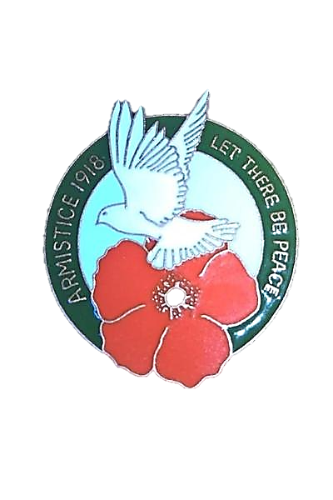
In this issue
Christmas
The Armistice Centennial
November Communion
…And a New Year begins!

Contents
(please note that due to illness, this online issue of the magazine is an abridged version of the printed magazine – the full magazine, including word puzzles and Remembrance poems, is available in printed form from the church)

From the Minister

Our World this Christmas

We live in strange times. Brexit and Independence are two of the big issues that face us as a nation – how will things finally pan out? When you look at the political chaos in both the Labour and Conservative party, the future seems a worrying place. On the one hand there is the re-emergence of the “loony left” with worrying chimes of intolerance and antisemitism and on the other side there seems to be no end to the in-fighting that is taking place, with some in high office scarcely fit to run their own lives, never mind the country. Here in Scotland, the ruling party, proud of its gradual abandoning of traditional Christian morality, is facing its own crisis.

The Church of Scotland [oor Kirk] is facing its own time of crisis and uncertainty: what is our future – that seemed so clear and certain less than 50 years ago – going to be like in five, or ten years’ time?

Our young people are facing up to their own demons. They are living in a post-Christian age now, where the old moral and spiritual certainties are long gone. They are living in a culture of moral and spiritual relativism; in a culture of confusion - personally, sexually, morally, spiritually; they are facing up to a new reality where “self” has now to make all the decisions about what is right and wrong, good or bad; they are increasingly cast adrift in a world where what you feel has to be right, and what you as an individual think is what governs your decisions.
Social Media is the new form of relationships, information and guidance. Social Media is how you view yourself and develop your thinking about reality – it is what fills your head and governs your life!

In this new age there is an appetite for spirituality, but correspondingly little appetite for God or Christ. People want to “find” themselves, and their spiritual search for meaning is to try and find something that will make them happy and fulfilled – it is a spirituality that is self- and not God-centred. Some may say that they believe in God [though for the first time in a census, less than half of Scotland say they now believe in God] but this is either some vague concept of a deity that they are prepared to believe in only if this deity works for them. Indeed, even in some schools [increasingly so] chaplains are warned not to express their beliefs for fear of offending pupils, parents or

teachers. In Fife there are more secular than religious funerals as people abandon the strong and powerful statements of faith and eternal life to concentrate only on the life of the deceased. Even the Guides have dropped God from their vows for an entirely innocuous alternative.

Our world, in the West, has altered so fundamentally - but that is also true of other parts of the world where, conversely, there has been an unprecedented outpouring of the Spirit and revivals that are bringing hundreds of millions to faith - in Africa and Asia in particular.

It is into this world that Jesus came. It was just as imperfect and confused and violent and misguided as it is today – that is why He came. That is why He had to come. Once again, we face a Christmas that is highjacked by the god of Mammon, while the real story is fast forgotten. Sure, there will still be nativity plays in schools and other places where parents will take photographs of their children playing their part in what will be presented as a lovely story. Lovely story? Really? A couple so poor they had nowhere else to stay other than in a cave where the animals were kept; a society so indifferent that there was no-one prepared either to give up a room, or make room, for a young woman about to give birth! The same old selfish society that was, and is still, broken and in need of someone to mend it. It is to that, and this world, that the Saviour came and still comes.

Yes, things are changing, but as we approach this Christmas with wonder, reverence and awe we need to prepare for the hard work that lies ahead of us as we leave Christmas behind and seek to make a positive impact on our society with the “real thing.”
We are being called to faithful service in a society that is ever-increasingly careless and disregarding of God and His will. There will be no quick fix, but, as it was for Jesus, a hard road ahead – a road of disciplined faithfulness and service to the Kingdom – a wonderful and glorious Kingdom. We are called to be authentic followers of Jesus and to fearlessly tell out the story of the Gospel in Word and deed, and all to the glory of the One who came into the ignominy of the Stable and suffered the shame of the Cross in order that we might be saved.

Iain

The Roof

The work on the roof and bell tower is well under way and we have so much to be thankful for:
- Not one grant application was refused that we applied for and that alone has raised over £100,000.
- Gift Aid has raised over nearly £20,000 – so a big thank you to the generosity of a benevolent government.
- The Café has raised over nearly £20,000 and so a huge thank you to everyone who runs the café and those who support the café. Hug-a- mug has made their contribution to this project too.
- We are fortunate to have £40,000 of reserves that was prudently put aside for such a times as this.
- Members of the congregation have donated over £70,000 – you all know who you are and my thanks to each and every one who has donated.

What makes me confident that this has been the right thing for us to do is the considerable rotten wood that has been taken from the roof and the fact that had we not done what we are now doing the roof and bell tower would have further degenerated and cost considerably more – probably more than we would have been able to afford!
Thank you to everyone who has made this possible and for all who have prayed for the success of the project.

God Bless,

Iain

Family Worker

It is part of the Plan of this congregation that we employ someone who will be responsible for reaching out into our community and seeking to attract people into our church. Over the past 12 months Alistair has been working full-time hours on a part-time contract to attract people, organisations and funding into our church:
- He has worked with the existing Family Night and encouraged young families into church.
- He has supported young women who wanted to set up a community café on a Tuesday – they have not only brought people in on a Tuesday and supported Alan’s Café [Restoration] but have also raised £1600 for the church.
- He has supported a mental health initiative - that had nowhere else to go and no funding to find a home - with us on a Tuesday morning.
- There is a support group on a Thursday for foster carers and adopters which meets in the Session Room.
- The Hub has been set up in the lower hall and is being used to teach computer skills and for other organisations.
- He is actively working with the council, council officials, schools and other organisations to find ways in which we might serve the community.

What all of this has done over the last year, is to show us that our community is receptive to our church and what it has to offer. The minister will be starting an alternative form of service for the younger families that are coming around church to see where this takes us.

However, it has become evident that the post that we thought was part-time will only work if it is full-time. We cannot expect Alistair [or anyone else] to receive a part-time salary for working full-time. We are going to try and find streams of funding to address this. However, a couple of years back there were some people who did say they would be willing to help fund this post and so the offer goes out again to anyone who might like to give weekly, monthly or as a one-off to help us maintain this post – please see either Moira Watson, the Treasurer or the Minister.

St Margaret’s Services Online

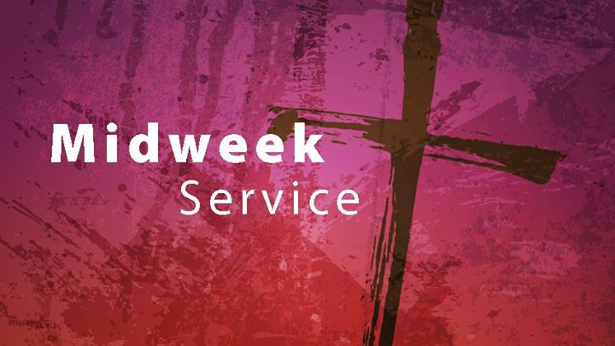
Did you know that there is midweek service in the church every Wednesday from 7.15 to 8.00pm? This service is not a Bible Study but an opportunity for worship and fellowship, and an opportunity to be refreshed by God’s Word. It is informal, is held in the sanctuary and is semi-traditional in style. Why not come along and see for yourself?

And did you know that these and all of our Sunday services are live-streamed? – you simply go on to the Web Site (by keying in www.stmargscos.org.uk )
and follow the link to the live stream. By doing so, you can also access videos of a whole range of past services – just follow the link to Dunfermline St Margaret’s Church of Scotland You Tube Channel. If you click the “subscribe” button you’ll find it easier to access, and you’ll be alerted to any new videos that become available.

With respect to the Web Site – see above – please log on to see what is happening or to avail yourself of any of the services that are to be found there. Would organisations also note that it is important that they pass information on to either Morna or Ally in order to keep things up to date.

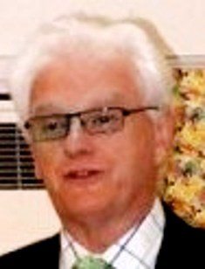
FROM THE EDITOR.

HELLO –
I am writing this in October and the sun is splitting the skies and it is the warmest October day we have had in years! I only hope it continues. We cover a lot of emotions in this edition – Remembrance Day, Communion, Christmas and New Year - all varied with special – and different - moments for each of us. Remembrance Day conjures up the sacrifice others made for us in not only the two great wars but also every war including sadly those that are still raging across the world. When will it all stop!
Communion celebrates the last supper that Jesus had with his disciples and which we replicate with our Communion. Communion remembers the days prior to the crucifixion of Jesus and we then move to the exciting emotion of the birth of the baby Jesus at Christmas with a totally different kind of celebration! New Year of course is not a Christian celebration, but it is the start of another year when we all hope for better things throughout the world and allows us perhaps to reflect how well we are off compared to some of the conditions people have to live in elsewhere. It also reflects how quickly the years seem to fly!!
By the time this goes to print the roof work should be almost finished and we can hopefully relax a bit and marvel at how our prayers have been answered in terms of raising what did seem like an almost impossible amount of money and Iain never did accept the fact that this would not be the case. I remember how Iain raised the point of the “power of prayer” and people did respond.
We also used this “power” when deciding to appoint a Family and Youth worker and this is proving so successful that the role is moving from a part time position to full time and the need to prepare a small office to administer this project. Well done to Ally – and a lot more still to come. I have used the word “remember” a few times in this piece but we should also think

practically about what is still to come and the drive that is needed to achieve the goals of the St. Margaret’s Action Plan – and the use of the “power of prayer” to help us along the way.
A very happy Christmas to you all and a healthy and peaceful New Year for us all.
REMEMBER – YOU ARE NOT ALONE.
A THANK YOU FROM THE EDITOR
As we approach the end of another year, I do want to thank everyone who helps to produce the Church Magazine – it “does not just happen” as the saying goes. I know I can be a bit of a pain at times when I press for articles for the magazine – but it is a magazine that should reflect the mood, activities and the workings of our Church within our community. A great deal of unseen work goes on behind the scenes to produce each edition and I would like to thank:
- Irene Cunningham (backed up by Jim) for copying all the pages we require each time. We run off 190 copies!!
- Morna Thomson who prepares the magazine for our web site. She also helps with the “design” of the front page and other pages that require a bit more of a technical approach!
- To everyone who contributes to the pages of the magazine. Without you the magazine would not appear.
- To the distributors who tirelessly deliver the magazine – without you the magazine would not reach those spread across our Parish.
- To Audrey McArthur, Alex Turner, Janet Kerr who help me each time we “put the magazine together” – this means stapling 190 copies of the pages we produce. Paint dries quicker!
- To you all for allowing me to Edit the magazine and to Iain for giving me the freedom to do so
- And finally, my hopes that you will continue to do so in 2019!

Ross Kerr (Ed)

All those who have suffered, all those who have sacrificed, all those who have fought, all those who have died
in war.
St Margaret’s Service for
Remembrance Sunday
11th November 2018
At 10am
(with the Remembrance wreath being taken as always to Dunfermline Cenotaph after the Service – this year especially commemorating the 100th anniversary of Armistice)

COMMUNION
THE KIRK SESSION WARMLY INVITES YOU TO COMMUNION
DATE : Sunday 18th November, 2018
TIMES: 10 am
7.30 pm
We look forward very much indeed to welcoming you to either or both of the service. (If you have not “tried” the evening communion before do come along. It is a shorter, more “personal” perhaps and most who attend also attend the morning Communion! Ed)

COMMUNION DUTY
Sunday 18th November, 2018
Session Clerk: Ritchie Campbell
Senior Elder: Ross Kerr
1. J Colville 5. S Foxley
2. J Adamson 6. I Telfer
3. Mrs L Adamson 7 A Prentice
4. J McLean 8. Mrs A Prentice
Reserve: Mrs S Richards
(NOTE: The communion duty list for the full year is on the next page. Ed)

St Margaret’s Parish Church Communion Duty 2018
Sunday March 18th
Session Clerk: Ritchie Campbell
Senior Elder: Walter Bowie
1. J Colville 5. S Foxley
2. J Adamson 6. I Telfer
3. Mrs L Adamson 7. A Prentice
4. J McLean 8. Mrs A Prentice
Reserve: Mrs E Pratt
___________________________________________________________________________
Sunday June 17th
Session Clerk Ritchie Campbell
Senior Elder: Walter Faichney
1. Mrs M Aitken 5. T McIntosh
2. Mrs Fiona Grieve 6. Mrs M McIntosh
3. J Grieve 7. D Clark
4 Mrs A McArthur 8. J Anderson
Reserve: Mrs S Richards
__________________________________________________________________________
Sunday September 17th
Session Clerk: Ritchie Campbell
Senior Elder: Millar Gordon
1. Mrs I Cunningham 5 J Thomson
2. Mrs I Gillespie 6. Manuel Giraldis
3. Mrs J McAleece 7. D Clark
4 Mrs J Gresty 8 Mrs J Eadie
Reserve: Mrs M Watson
__________________________________________________________________________
Sunday November 18th
Session Clerk: Ritchie Campbell
Senior Elder: Ross Kerr
1. J Colville 5. S Foxley
2. J Adamson 6. I Telfer
3. Mrs L Adamson 7 A Prentice
4. J McLean 8. Mrs A Prentice
Reserve: Mrs S Richards

At St Margaret’s this Christmas
2nd December – 1st Sunday in Advent
10.30am Youth Service

9th December – 2nd Sunday in Advent
10.30am Morning Worship
2.30pm A short act of Worship for anyone who has been touched by the loss of loved ones this year
(there will be light refreshments in the hall at the close of the Service and the opportunity to share memories)

16th December – 3rd Sunday in Advent
10.30am Morning Worship

23rd December – 4th Sunday in Advent
10.30am Morning Worship

(Monday) 24th December – Christmas Eve
10.30pm for mince pies and refreshments
11.15pm Watchnight Service

(Tuesday) 25th December – Christmas Day
10.30am short Family Service

Toccata Choir Christmas Concert

St Margaret’s Christmas Celebration, featuring this much-loved, award-winning choir, as well community singing of Chrristmas carols and songs, including the now famous St Margaret’s “12 Days of Christmas”

Tuesday 11th December

@7pm

Tickets £6

(includes refreshments)

Last year was a sell-out,
so do get your tickets early!

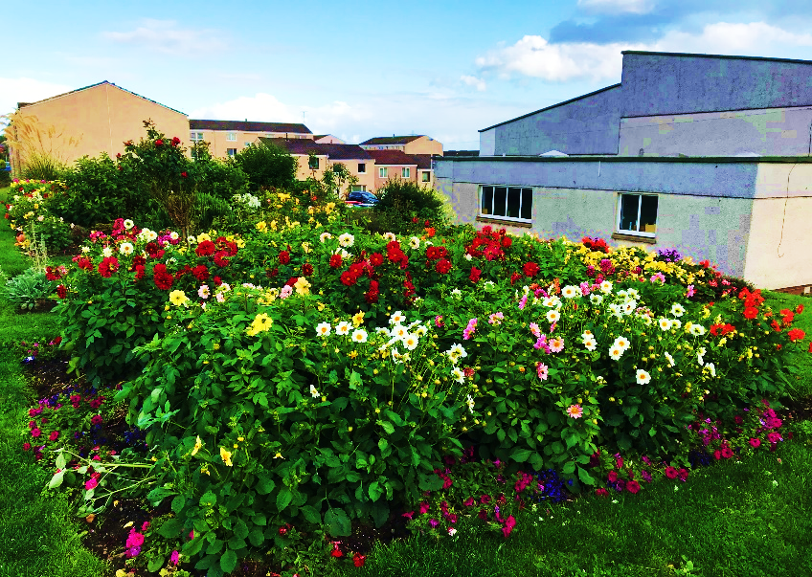
ST MARGARET’S
COMMUNITY GARDEN

Our Garden
in full bloom!
We are indeed fortunate to have such a dedicated (small) team working very hard to keep our garden looking so good. The great thing about the garden is that it is seen almost as the community garden with many of the residents who pass with very complimentary comments. Our church is about “community” and it is good that the garden is appreciated by our neighbours. The garden does of course not just “appear” in all its glory. As indicated, we have a very dedicated small team that put in a power of work - Team leader is the very enthusiastic Tom McIntosh with assistance from Walter and Nancy Bowie and their grandson Calum, Marjory, David, Margaret Scoon and John Rodgers.
August 2018
On your behalf I would like to thank Tom and his team on helping to make our Church and surrounding area “bright and welcoming”! (Editor)
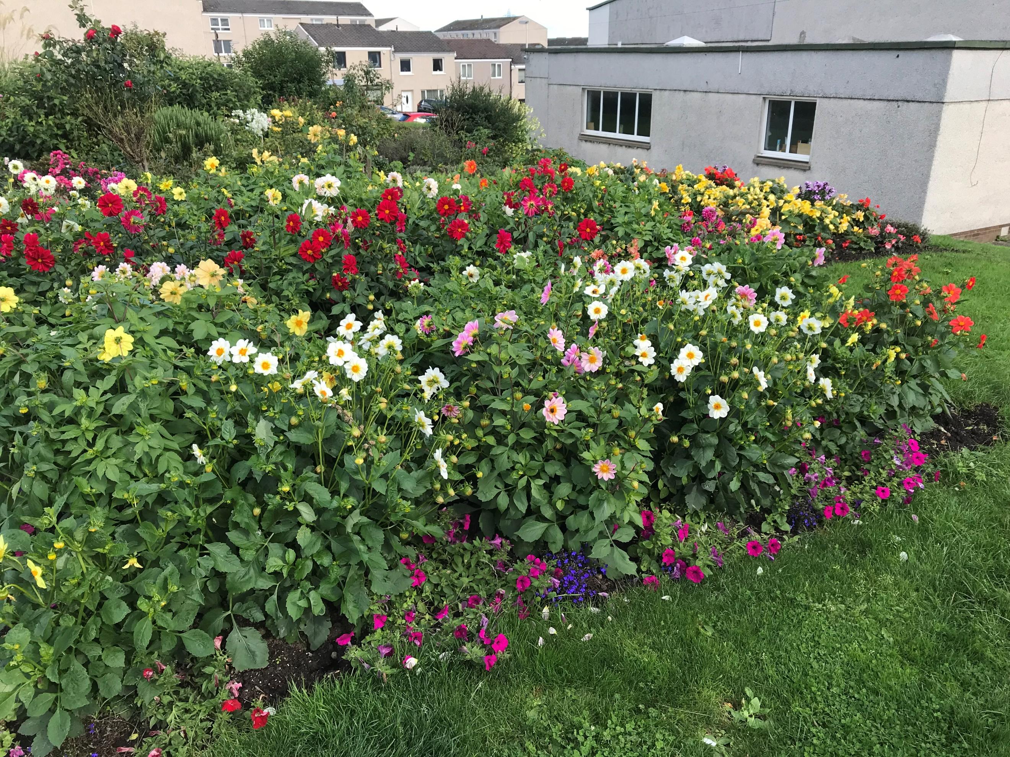

2017
Summer 2016
From the Head Gardener:

An appreciation of those who have helped

“When I was asked by the Property Convenor in March, 2015, to create a community garden at St Margaret’s, I approached members of our congregation to enquire if they would like to assist with this development. Walter, Nancy, David Clark, Marjory, Robert Grant and Walter’s grandson, Calum, became part of the team. It was a fantastic team effort and the whole area has benefitted.

I wish to thank, Walter, Nancy Marjory, David, Margaret Scoon and John Rodgers for their support in maintaining the garden and church grounds. We wish to thank members of the congregation for their kind financial support and plant donations over the past three years.

Sadly, we lost a stalwart member of our team this year – Robert Grant.
After getting to know Robert, I found out that most of his life he has been involved in some way with horticulture and had been the Manager of several nurseries including the Co-Operative Nursey in Crossford.

Robert’s knowledge of plants was second to none and he was responsible for bringing on the beautiful display of dahlias, begonias and lupins. Every year Robert lifted the plants, dried them off and stored them in preparation for the next season. Robert had not been well for over a year and felt guilty because he was not able to do as much as he wanted to do in the garden. I would say to him, ‘your job is to bring the plants on and the rest of the team will do the planting and maintenance of the garden.’

Robert, his humour, skills and expertise will be sorely missed and our thoughts and prayers are with Moireen, daughter Carol and the rest of the family
during this sad time.
Robert requested, at his funeral service, that donations be given to the
Church Community Garden Fund.”

Tom McIntosh

ST MARGARET’S MEN’S GROUP - PROGRAMME FOR 2018-19

17 NOVEMBER – “Diabetes, prevention or cure: is either even possible?”
Discussion led by Dr Calum Sutherland, Molecular & Clinical Medicine, University of Dundee, Ninewells Hospital.

8 DECEMBER – “What do we believe about the Christmas story?”

Discussion led by Morag Wilkinson, translator, worship leader and well known to us all.

……………………………………………………

9 FEBRUARY – Joint meeting with F&C at Crook of Devon church hall – Topic still to be decided

16 MARCH – “Nepal, 3 years after the earthquake – an eye-witness account.”

Presentation and discussion led by David Chisholm, military engineer with construction experience, who has worked within project management since leaving the Army.

13 APRIL – “What do we believe about the promised Second Coming of Jesus?”

Discussion led by Sandy Muirhead, former criminal defence lawyer, now pursuing Readership and other ministries –
also well known to us.

……………..

Free picture with Santa!

Saturday 17th November 2018
noon-3pm
at St Margaret’s Church, Abel Place, Touch
Tombola- bottle stall- chocolates-bric-a-brac-crafts-home baking- games and seasonal activities for children- CAFÉ open for refreshments/light lunches

Proceeds go to St Margaret’s Church

SCOUT CHRISTMAS POST FOR 35p
You can have your Christmas Cards delivered by the SCOUTS in Fife to the following Towns and Villages:
ABERDOUR, ALLOA, ALVA,
BACKMUIR, BALMALCOLM, BLAIRHALL, BOWERSHALL,
CAIRNEYHILL, CARNOCK, CHARLESTOWN, CLACKMANNAN, COALEDGE VILLAGE, COMRIE, COWDENBEATH, COWSTRANDBURN, CROMBIE, CROSSFORD, CROSSGATES, CULROSS,
DALGETY BAY, DOLLAR, DONIBRISTLE VILLAGE, DUNDUFF, DUNFERMLINE,
FORDELL VILLAGE, FREUCHIE, GOWKHALL, HALBEATH, HIGH VALLEYFIELD, HILL OF BEATH, HILLEND, INVERKEITHING, KELTY, KINCARDINE, KINGSEAT,
LIMEKILNS, LOCHGELLY, LOW VALLEYFIELD, LUMPHINNANS, MENSTRIE, MUCKART,
NEWMILLS, NEWTON OF FALKLAND, NORTH QUEENSFERRY, OAKLEY,
PATTIESMUIR, PITLESSIE, ROSYTH, SALINE, SAUCHIE, STEELEND, STRATHMIGLO,
TILLICOULTRY, TORRYBURN, TOWNHILL, TULLIBODY & WELLWOOD
PLEASE NOTE CARDS WILL NOT BE DELIVERED TO AREAS OTHER THAN THOSE MENTIONED ABOVE
ST MARGARET’S UPLIFT IS ON 2ND OR 9TH DECEMBER ONLY
LAST DAY FOR COLLECTION IS WEDNESDAY 12TH DECEMBER BEFORE 5PM (SHOPS)
& 7.30PM AT SCOUT HALLS
Cards will be delivered from 15th to 21st December 2018

SCOUT NEWS
39th Fife Scouts GSL Graham McReadie
FOR ONLINE MAGAZINE, PLEASE GO TO:

http://www.39thfifescouts.co.uk/

J.A.M. Club
Hello everyone! It’s good to be able to share our news with you once again. We have continued to meet each Sunday evening, enjoying our time together and happily welcoming some “new” faces. For several weeks we have used science experiments, to engage the children’s interest. One of our topics was ANGER. The children worked (with great enthusiasm!) in pairs to create “volcanic eruptions!” We discussed how anger makes us feel and went on to show a video of Jesus cleansing the temple...many children were shocked that he could display anger. This led us on to talk about righteous anger. So, a fun experiment played a meaningful part in relaying our Christian message.
Gordon, our Reader, recently asked me if I felt that J.A.M. Club had evolved over the years. In answer to his question......a resounding YES! Although, like most people, our team recognizes that change can be hard, we all feel it has been essential to adapt to ever-varying needs and the practical demands of our group of children. We have truly been “kept on our toes!” Each child who comes to us is unique and therefore brings his or her own expectations, talents, social skills and perception of life in general. I came upon a lovely poem which I’d like to share with you......it sums up these thoughts well.

Butterfly in the Wind
A child is a butterfly in the wind,
some can fly higher than others....
but each one flies the best it can.
Why compare one against the other?
Each one is different! Each one is special! Each one is beautiful!

We are delighted that several of our members have been with us for many years now. They have helped us try many different approaches, activities and participated in new ventures. As a team we recognize that these young people now need more mature experiences and challenges.
I am delighted to tell you that Ally will be working with these youngsters. We will share times together each week but also split into 2 groups for part of the time.
The topics which the older children cover will have a Christian perspective but will allow them to ask questions and discuss their concerns at an appropriate level. Young people today have never needed such input more and I’m confident that this opportunity will benefit our “seniors.” As a rite of passage for these boys and girls each will be given a copy of the Authentic Youth Bible. (If you haven’t seen this version, I’m happy to let you borrow my copy.)

Each week we continue to ask the boys and girls to offer suggestions for prayer. Young Keiran was clearly shocked by scenes of disasters caused by severe weather conditions.....so (in addition to our prayers) we intend organising a fundraiser, the proceeds of which will benefit people who have suffered as a result of storm damage.

The weather in our own part of the world can become very unpleasant as Winter approaches....but, for the most part, our lives continue as usual. Thoughts of Christmas celebrations cheer us and at J.A.M. Club we love to share the joy of our Saviour’s birth with everyone. We plan to invite our boys and girls (also their families) to our Christmas family service. Following the service there will be an opportunity to celebrate with a party buffet and fun activities.
From the festive season we all move on to a new year. It will again be a chance for all of us at J.A.M. Club to reflect on what has gone well and also make us think about how we evolve and move on. May we wish you a happy, healthy 2019 filled with blessings......and ask, in return, for your prayerful support of the young people in our church family at St Margaret’s. God bless you all!

Games time at JAM Club!

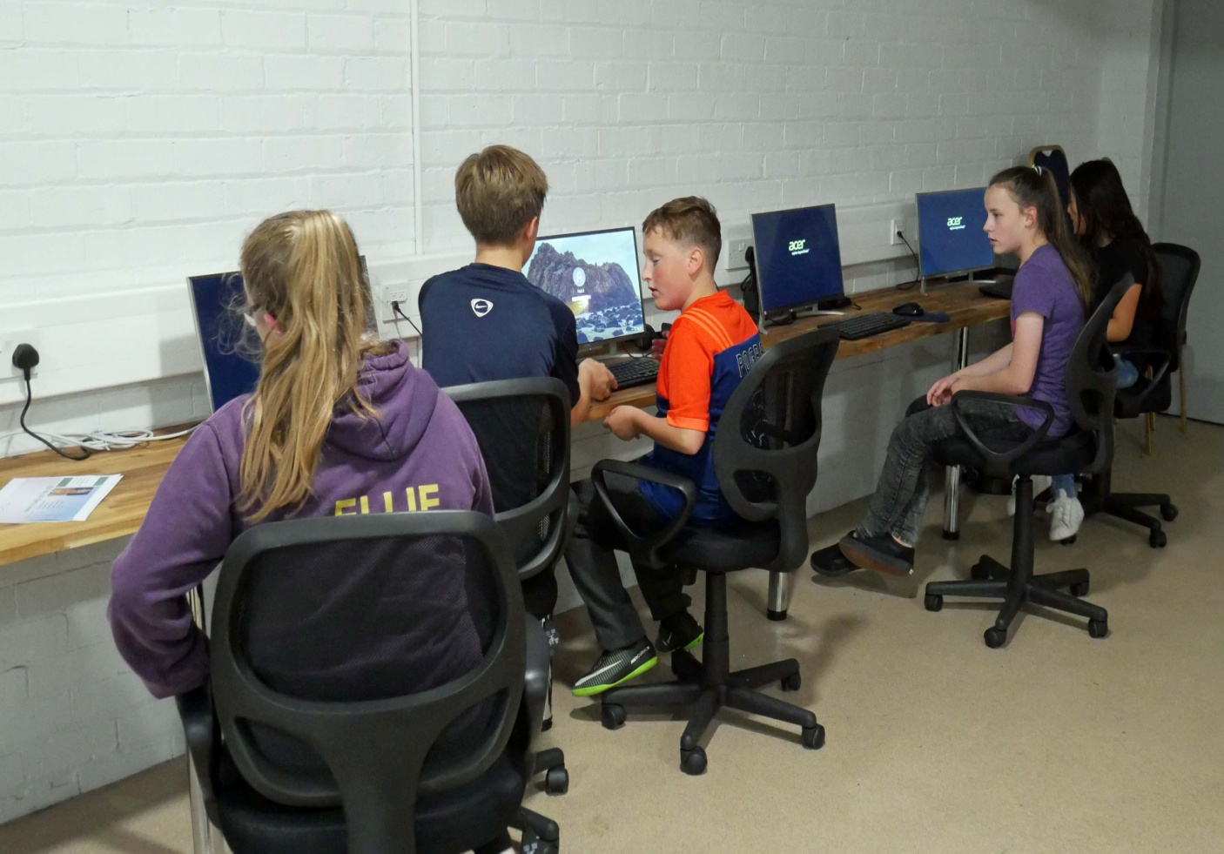

JAM Club members using The Hub facilities!

Pastoral Care Update!

It’s been a wee while since we let folks know what has been happening in relation to this area of church life so we hope this will enlighten you! As always, members of the Pastoral Care Committee treat their role very seriously and try hard to ensure that members of our congregation, who are unable to attend church, are visited and included in the life of the church as much as possible. However, due to increasing demands, sometimes it’s difficult to give the level of care we feel folk deserve-but please be assured we are trying our best!
Having said that, we would like to thank those who have been kind enough to pass on any queries, concerns or indeed good news to members of the committee. Good levels of communication are so important!
The Handyman Service is still available and we would encourage you to ask John Thomson for assistance when you are faced with any of those wee jobs which need a “helping hand.”
In May we invited Faye Smart and Janine Adair (Dementia Advisors for Fife) to visit our church. The aim was to raise awareness and understanding of Alzheimer’s/Dementia. The ladies gave an excellent insight into the challenges facing someone living with such illness but they explained that it is also possible to continue to enjoy life whilst living with this condition. Following the presentation, an assessment of the church building and surroundings was made. Faye and Janine helped us recognize where we might make some simple changes which would benefit anyone living with Dementia-thus helping them continue attending church for as long as possible.
At present, the focus is currently the major job of replacing the roof-but we aim to attempt making the changes (mentioned earlier) as soon as possible.
In September Jim, Joyce and Linda (not forgetting Lucy, Joyce’s wee Westie!) participated in the Alzheimer Scotland Memory Walk at Lochore Meadows. A coffee morning following Sunday service was also held in the Rita Elder Hall. In total a magnificent £1100, including Gift Aid, was raised. Our thanks go to all who contributed so generously, in any way, to this worthy cause.
On 4th October we visited the Sunshine Group at Dalgety Bay Church. This group meets once a fortnight on a Thursday afternoon. It provides a wonderful opportunity for people living with Dementia to enjoy a time when they can chat and enjoy tea/coffee and biscuits.....followed by singing well-known songs (and dancing too!) When we were there, it was hard to decide who enjoyed the afternoon most- as Carers seemed to be having as much fun as the folks they accompanied!
At present, we are in the very early stages of investigating possibilities but it would be wonderful to develop a similar group at St Margaret’s. Watch this space!

WHEN IS £1.00 WORTH £1.25??
When you GIFT AID it!

A donation is worth more with GIFT AID -
PLEASE sign a gift aid declaration

If you are a tax payer and not already in
The Gift Aid scheme for any donations made to St. Margaret’s then PLEASE
Contact Audrey McArthur
At Church or on
728128

(Audrey McArthur does a great job reclaiming thousands of pounds for St. Margaret’s from the tax man. You can help if you have not already signed up for the Gift Aid Scheme. For every pound you donate Audrey can turn that into £1.25 so PLEASE contact her to sign up for this scheme – and the GREAT news is that it costs you
NOTHING, ZERO, ZILCH.
So WHY are you waiting!!
Ed)

SPIRITUAL
ENCOURAGEMENT
FUND

As part of the goals for the Christian Education and Worship (CEW) Committee contained within our Mission Action Plan (MAP) approved by the Kirk Session (KS) in 2017, it was agreed to establish a Fund, from legacies, donations or Church funds, to encourage spiritual development.
This Fund will be operated by the Minister and Session Clerk and is open to all those belonging to St Margaret’s Parish Church for their own personal development and the benefit of the Church.
Enquiries/applications for support should be made in the first instance and thereafter in writing to:

Rev Iain Greenshields
38 Garvock Hill, Dunfermline, KY12 7UU
Tel: 01383 723955: Mob: 07427 477 575

Mr Ritchie Campbell
Session Clerk
1 Pitbauchlie Bank, Dunfermline
Tel: 01383 725516

SPIRITUAL LEARNING
Back in May we launched the “Spiritual Encouragement Initiative”. The aim is to deepen our faith and give us the confidence to share it with others. We want to encourage all members of the congregation to undertake at least one “spiritual learning activity” each year.
We have also created a Fund to help us, if necessary, with the costs of attending events and conferences, undertaking courses or acquiring material and resources. Applications for some assistance can be made to the Minister or Session Clerk, Ritchie Campbell.
Learning activities can be undertaken on our own or by getting together with others and there are so many different ways in which we can learn and grow spiritually.
We don’t even have to leave our homes. For example, order books online and Amazon will deliver to your door (next day if you are a Prime member!) I’ve recently bought and read two spiritual books – “One Life” by Phil Moore, Pastor at Everyday Evangelical Church, London and “Parables to Ponder” by Phil & Patti Moore, American bible scholars and writers (no relation to the other Phil Moore).
During the Edinburgh Festival I attended a (free) discussion about “faith in politics” in St John’s Episcopal Church.
While on holiday, we joined congregations of other denominations with different approaches to worship – it was challenging, in some cases inspiring and uplifting, and it gave me ideas which we might use during worship in St Margaret’s.
Music is another means by which we can learn and grow spiritually.
I’ve been looking for good, new Christian worship songs. One such, which I first heard sung at Charlotte Baptist Chapel in Edinburgh, is “The Potter’s Hand”. I found the words so powerful I based the sermon message upon it at our last Halbeath service.
I’ve also found a fantastic worship band “Cityalight” – which leads the singing at services in St Paul’s Castle Hill Anglican Church in the Hills District of Sydney, Australia. Every song I’ve sourced has thought provoking lyrics and great tunes. I hope to find ways of using some of these songs in worship at St Margaret’s.
We have so much to learn spiritually from each other, especially when we mix with people from different backgrounds, perspectives and practices. As you may have noted, my recent learning experiences have come from Evangelical, Scottish Episcopal, Baptist and Anglican worship centres.
Let’s share our spiritual learning activities with each other through this magazine, the website or simply by telling one another about them. Gordon Brown

St Margaret’s e-Prayer Group
Do you know that we have a Prayer Group at St Margaret’s?
This was set up at the Minister’s request..
It is an “e” group, ie we do not meet together but requests are passed around via email,
Is there anything or anyone that you feel you might like the group to pray for?
You may rest assured that all requests are treated in confidence, only conveying what you wish. Emember, it is always good to know hat others are holding you in their thoughts at times of difficulty and adding their prayers to yours.
You might feel that you would like to be part of the group. If so, you do need to have an email address for contact.
If you do have a request or would like to be part of the group then please do get in touch:
Vera Wilson
Group Co-ordinator
Tel 01383 720250
Email: veewilson@btinternet.com

(The more we have, the more the impact! So why not contact Vera to be put on the list? You are contacted by email, so it is quite painless – but does a LOT of good – and who knows when you might want a prayer for someone close to you. Well done Vera for setting this up. Ed)

:

FLOWER CALENDAR 2019
For the past year, once again, the flower arrangers have been most grateful to the members of the congregation who have kindly donated towards the flowers which grace our church each Sunday as a way of marking special anniversaries.
If you have a special day you would like to be commemorated in the church please add your name to the flower calendar on the vestibule table, or contact June McAleece on 724992.
Many thanks to the flower arrangers whose skill and talent delight us each week. Anyone who would like to join them will be most welcome.

Best wishes to all for a happy and peaceful 2019.
June McAleece

(We are indeed fortunate to have such a marvellous display of flowers each week in the Church. Well done to all. – Ed)

NB Calendar for 2019 is in process of being completed

SUNDAY MORNING TEA/COFFEE ROTA
:

November, 2018 | 04 | Mrs Irene Cunningham | Mrs June McAleece | Mrs Isobel Gillespie
 |  | Mrs Marjory McIntosh | Mrs Marion Smith | Mr Tom McIntosh
 | 11 | Mrs Ann Prentice | Mrs Ann McEwen | Mrs Margaret Orr
 | 18 | Mrs Vera Wilson | Mrs Sarah Richards | Mrs Catherine McCulloch
 | 25 | Mrs Catherine Gray | Mrs Margaret Hynd | Mrs Jennifer Grieve

December, 2018 | 02 | Mrs Irene Cunningham | Mrs June McAleece | Mrs Isobel Gillespie
 |  | Mrs Ann Prentice | Mrs Jeanette Clements | Mrs Margaret Orr
 | 09 | Mrs Catherine Gray | Mrs Ann McEwen | Mrs Pam Moultrie
 | 16 | Mrs Vera Wilson | Mrs Margaret Hynd | Mrs Sarah Richards
 | 23 | Mrs Maureen Chapman | Mrs Catherine McCulloch | Mrs Jennifer Grieve
 | 30 | Mrs Marjory McIntosh | Mrs Marion Smith | Mr Tom McIntosh

January, 2019 | 06 | Mrs Irene Cunningham | Mrs June McAleece | Mrs Isobel Gillespie
 |  | Mrs Vera Wilson | Mrs Pam Moultrie | Mrs Sarah Richards
 | 13 | Mrs Catherine Gray | Mrs Jeanette Clements | Mrs Jennifer Grieve
 | 20 | Mrs Marjory McIntosh | Mr Tom McIntosh | Mrs Catherine McCulloch
 | 27 | Mrs Nancy Bowie | Mrs Ann McEwen | Mrs Margret Hynd

- Thanks to everyone named above for supporting the Tea/Coffee Rota
- Tea, coffee, sugar, mugs and teaspoons are permanently available in the Session Room, no need to bring down from kitchen unless stock is needing topped up.
- Please contact Marjory McIntosh, Tel: 726342. If you wish to join this Rota, your help will be much appreciated.

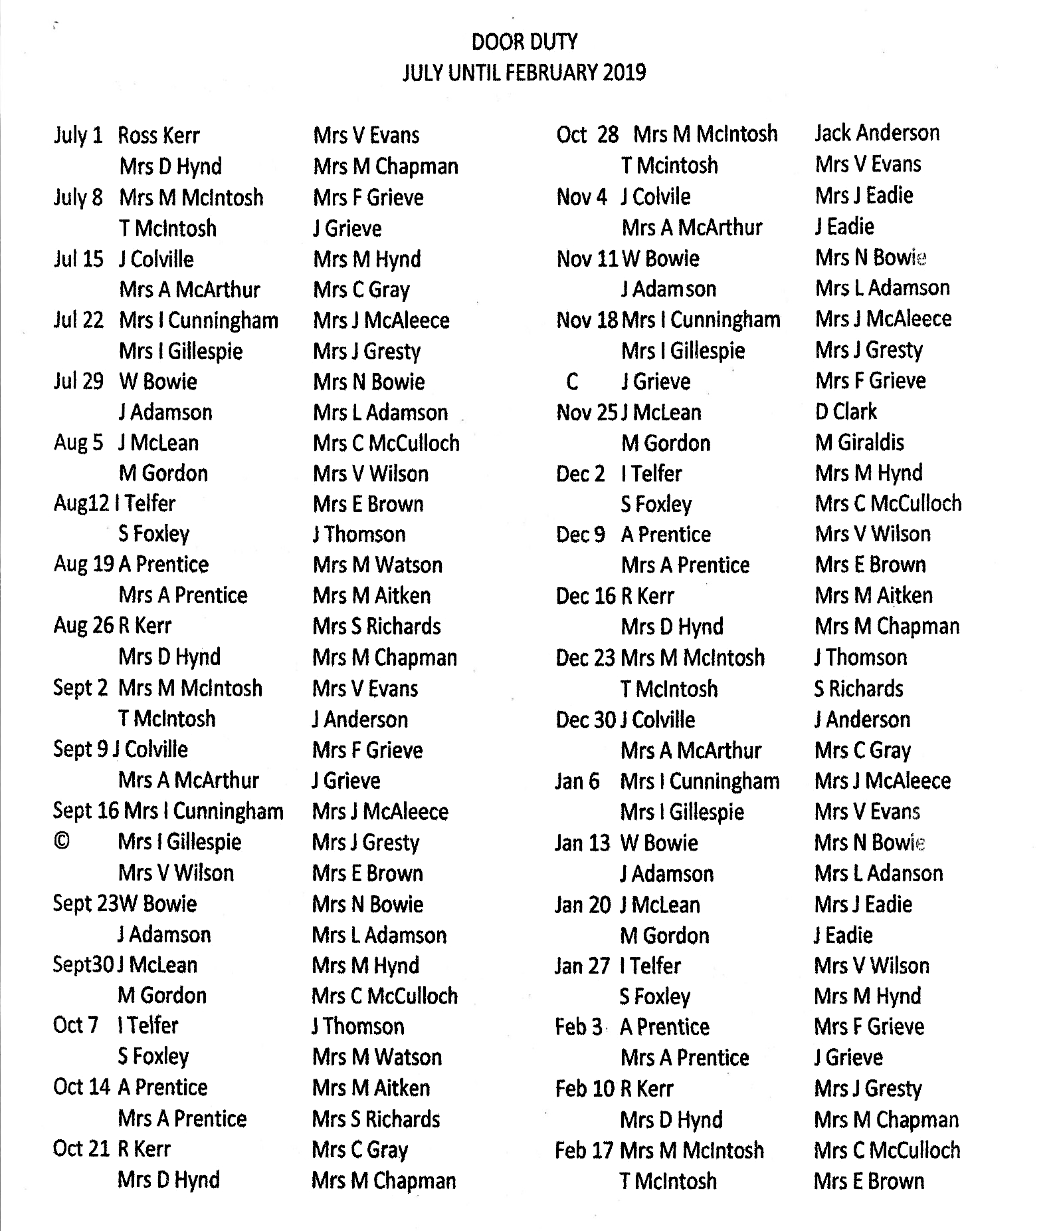
ORGANISATIONS
Bowling Fellowship - Meet on Mondays in the main hall at 6.30pm. Contact Tom McIntosh on 01383 726342
The Craft Group - Meet on Tuesdays in the Rita Elder Hall at 2.00pm. Contact Audrey McArthur on 01383 728128
The Guild - contact Margaret Hynd on 01383 721314
Swingnastics – Meet from September to May every Wednesday in the Rita Elder Hall at 10.00am Contact Catherine McCulloch on 01383 734463
Ladies Badminton - Meet for social Badminton every Wednesday at 10.00am - 12 noon in the Church Main Hall. Contact Cherry O’Sullivan on 01383 720594
Banner Group - Meet on Thursdays in the Rita Elder Hall at 2pm Contact June McAleece on 01383 724992
Men’s Breakfast Discussion Group – Meets periodically on a Saturday morning from September - May at 8.30am (see website or programme in the magazine for actual dates and/or contact Gordon Brown on 01577 840248)
Sunday Club & Crèche - Meet in the Church at 10.00am on Sundays during Morning Service, except during school holidays. Contact - Helen Webber on 01383 736486
JAM (Jesus And Me) CLUB –Meet Sundays in term time at 5.45pm - 7.15pm. Contact Linda Adamson on 07540 284027
Rainbows - Meet every Tuesday in the Rita Elder Hall at 6.15pm - 7.30pm Contact Anne Laird on 01383 727515
Brownies – 2nd Dunfermline Pack meet on Wednesdays in the Downstairs Hall 6.15pm - 7.45pm. Contact Susan Guild on 01383 727167
2nd Dunfermline Guides meet on Thursdays in term time, from 7.15-9.15pm.
For more information, please contact Anne Simpson on 01383 410490 or 07972181351

BEAVERS - CUB SCOUTS - SCOUTS - EXPLORER SCOUTS
Meet in the Scouts H.Q. Carron Grove
Contact GSL Graham McCreadie
Beavers - Mondays 6.30pm - 7.45pm
Cubs - Tuesdays 7.00pm - 8.30pm
Scouts - Wednesdays 7.30pm - 9.30pm
Explorer Scouts - Thursdays 7.00pm - 9.00pm

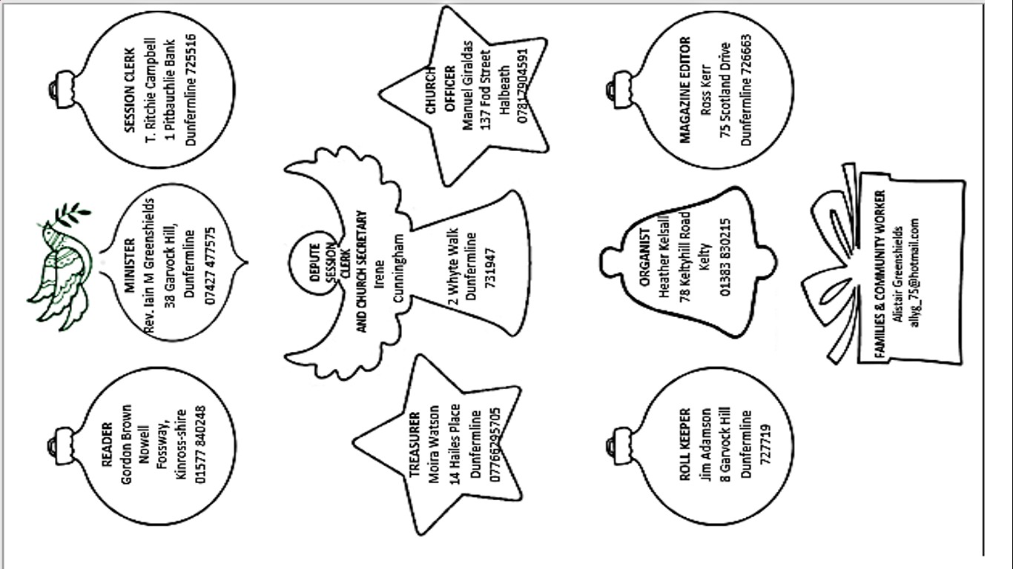
Church Contacts

