St. Margaret’s Community Church of Scotland Dunfermline
38 Garvock Hill, KY12 7UU
Iain Greenshields, Tel: 07427477575
Email: revimaclg@hotmail.co.uk

31st January 2021 Newsletter
You can never tell the difference you might make to another person’s life by acts of kindness.
Jurgen Moltmann came to faith during World War 2 when he was a captured German soldier in a British POW camp. He was taken prisoner in Belgium and transferred to a camp just outside Kilmarnock. Local Scottish women brought the enemy prisoners home-baked goods and a Bible. Moltmann was so touched by the kindness, he began to read the Bible he was given.
After the War he returned to Germany where he went on to serve as a church minister and eventually a theology professor. “The Church is where Christ is,” Moltmann went on to say, “and Christ was in these women who came to visit us.”
Did any of these women realise that one of these prisoners was going to become one of the most influential figures in the post-war German Church? Indeed, one of the most influential Christian thinkers of his generation in the post War world? Would he have come to faith from his Nazi agnosticism were it not for the kindness shown to him and the gift he was given?
By comparison Gandhi, when he was in South Africa, was invited to go along to a special evangelistic service by a friend. When he arrived with his friend at the church he was asked to leave because of the colour of his skin!! His friend was appalled at this and tried his best to reverse this decision but it was too late – the damage was done. His friend, a church minister reflected that “the greatest soul of the century was lost that day to Christianity because of that act of prejudice!
We see the difference that our actions can make!
We are living is what might be called a post Christian culture. What is meant by that is that we are no longer a society either with a significant number of Christians nor are we a society that has Christian teaching and morality as its reference point – that ship has sailed!
How are we going to have an impact on this society that has changed so dramatically in our own lifetime? Trying to teach our society will be futile because that has been tried and found wanting – words alone will make no difference.
Our culture needs to feel the difference and see the difference being a Christian makes. We seem to be waiting for people to enter our buildings and when they do, hear the good news. What in fact we should be doing is reaching out and touching the lives of those around us with compassion, kindness, hope and love in all of its manifestations. Only then will people feel and see the difference.
This time of lockdown has been for all of us a time of reflection and evaluation – a time when we can see clearly what it is that God is saying to us about the future and how we as a Church need to continue to connect in ways that make our local society sit up and take notice. What we say can matter, but what we do can leave a lasting impression on the mind and soul of people.
Iain
Intimations
Services will be at the normal times on Sunday – Facebook will go on at 9am, Zoom at 9.45.
Zoom Service on Wednesday at 6.45pm where we are looking at the life of St. Paul. This is a series of reflections by Con Campbell with the filming shot in situ.
Sadly we intimate that Alec Tocher died last week – his funeral service will be in the church on Monday 1st February.
Please pray too for Susan Guild our Brownie leader whose father William has died – his funeral service is on Tuesday 2nd February.

HYMN VERSES
Our chosen verse for this week comes from someone who wants to remain anonymous.
Our verse this week comes from hymn 419, Thine be the Glory and the final verse:

No more we doubt thee, glorious Prince of Life;
Life is naught without thee: aid us in our strife;
Make us more than conquerors through thy deathless love:
Bring us safe through Jordan to thy home above.

“I am someone who struggles with doubt. This verse never ceases to help me when it is sung at Easter.”
[If you have a verse from a hymn you would like to offer – even anonymously – just drop me a note or an email.]

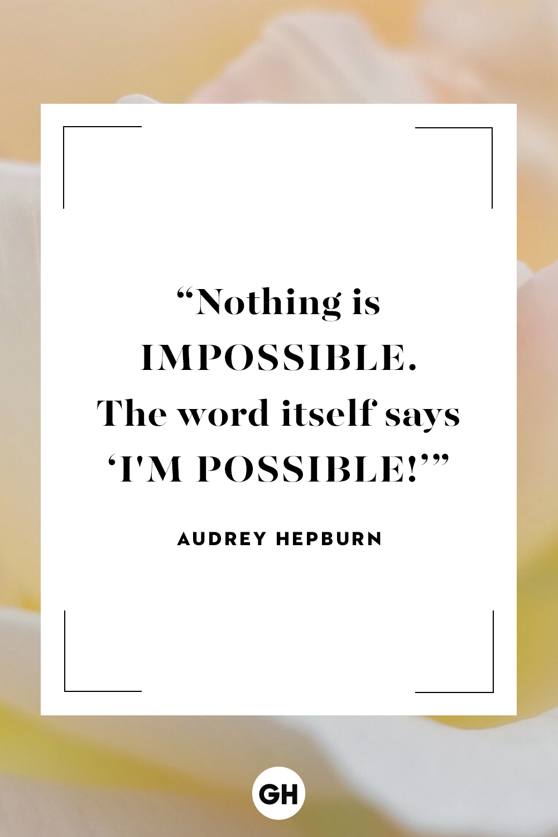

“You can't stay in your corner of the Forest waiting for others to come to you. You have to go to them sometimes.”
― A.A. Milne, Winnie-the-Pooh
“Always do what you are afraid to do.”
― Ralph Waldo Emerson
“Do not go where the path may lead, go instead where there is no path and leave a trail.”
― Ralph Waldo Emerson
“If you can't fly then run, if you can't run then walk, if you can't walk then crawl, but whatever you do you have to keep moving forward.”
― Martin Luther King Jr.

