St. Margaret’s Community Church of Scotland Dunfermline
38 Garvock Hill, KY12 7UU
Iain Greenshields, Tel: 07427477575
Email: revimaclg@hotmail.co.uk

7th February 2021 Newsletter
Paul Gauguin, the famous French artist from the late 1800’s painted a huge panel painting and across the corner of the painting he scrawled these words –“Who are we? Why are we here? Where are we going?” [If you are able to access Google then type in “Paul Gauguin Panel Triptych Who are we? Why are we here? Where are we going?” to see this painting].

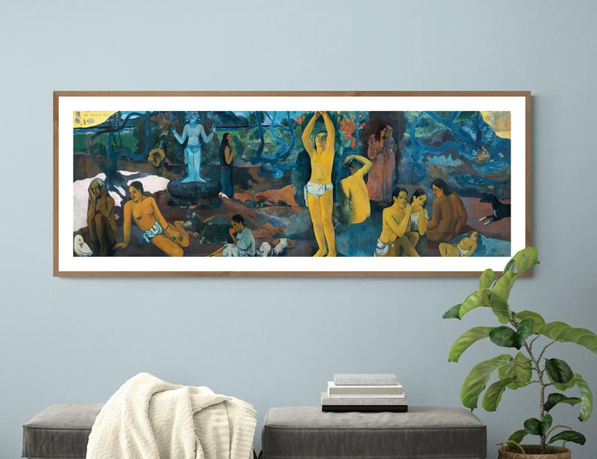
What was Gauguin’s purpose in painting something with these three questions?
This came from the Catholic catechism that he would have learned as a child – fundamental questions about life. The painting is set in Tahiti and depicts birth, young adulthood and an old woman who is facing death and the “Beyond.”
The painting and its questions are fascinating and pose quite fundamental questions that can only be answered by faith itself.
“Who are we? Our uniqueness surely lies in two things – first of all we are created in the image of God and secondly, that we are recreated in the image of Jesus Christ.
We are not simply the product of evolution whereby we are no more unique than the most humble creature on earth. We are uniquely invested with something of God.
Why are we here? The Westminster Shorter Catechism tells us that “our chief purpose is to glorify God and enjoy Him forever.” We are created to live God-honouring, purposeful lives that honour God by living according to His will – lives of service to others and our world – lives that count and make a difference. Lives that are rooted in love and express love. Lives whereby we recover, with God’s help, what we have lost of the image of God.
Where are we going? We are not surely like lost individuals wandering around in the dark with no idea where we are going? We have sufficient light to know that our destiny is in good and secure hands – in the hands on One that we can absolutely trust.
Our destiny? Resurrection! Surely that is the glory of being a Christian? We know who we are, where we have come from, why we are here and where we are going!
What difference ought all of this make? Peace! Surely this gives us peace of mind? We do not have the hand on the wheel but are active passengers on a journey through life knowing that this is just a staging post and that the best is yet to come.
May God fill our hearts and minds with living hope.
Iain
Intimations
Services will be at the normal times on Sunday – Facebook will go on at 9am, Zoom at 9.45.
Zoom Service on Wednesday at 6.45pm where we are looking at the life of Paul. This is a series of reflections by Con Campbell with the filming shot in situ.
The Executive will meet on Zoom at 3.00pm on Wednesday– please not the change in time but not in date.
Please also note that the Presbytery of Fife will meet on Saturday for the first time on Zoom – if you would like to pop in and see what is happening please let me know and I will provide the Zoom details to you.

HYMN VERSES
Our chosen verse for this week comes again from someone who wishes to remain anonymous.
Our verse this week comes from the hymn “Jesus loves me” which is number 563 and verse 3 in the Church Hymnary:

Jesus loves me! He will stay
Close beside me all the way;
He will always be my friend,
And his love will never end

“I have left out the chorus. The words are so simple but profound and reassuring and they often come back to me out of the blue!”
[If you have a verse from a hymn you would like to offer – even anonymously – just drop me a note or an email.]
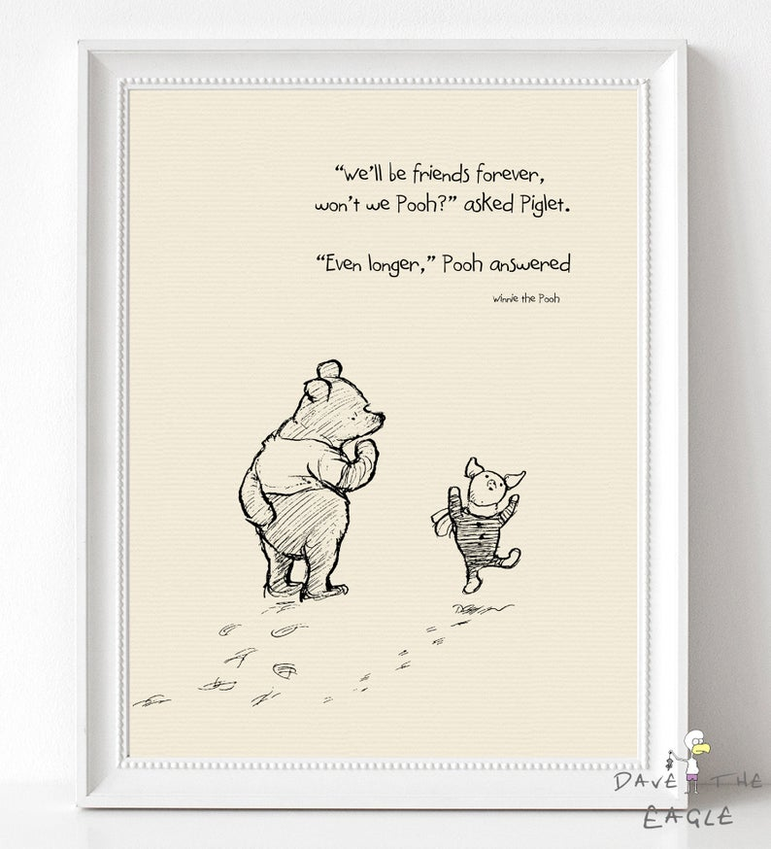

“Prayer is not asking. It is a longing of the soul. It is daily admission of one's weakness. It is better in prayer to have a heart without words than words without a heart.”
― Mahatma Gandhi

“The past is a place of reference, not a place of residence; the past is a place of learning, not a place of living.”
― Roy T. Bennett, The Light in the Heart

“Going to church doesn’t make you a Christian any more than going to a garage makes you an automobile.”– Billy Sunday

And finally…”Be very careful when you follow the masses because sometimes the “M” is silent.”

