St. Margaret’s Community Church of Scotland Dunfermline
38 Garvock Hill, KY12 7UU
Iain Greenshields, Tel: 07427477575
Email: revimaclg@hotmail.co.uk

11th April 2021 Newsletter
It becomes all too easy for Easter to pass and we think, “well that’s it over with for another year and so let us get on with the life of the Church.”
Think! Think seriously for a moment! Is that what happened a week after Jesus had risen from the dead? Did life just slip back into normal? Of course not! He kept appearing to people for over 40 days – to hundreds of people in order to impress upon them that He had risen and to teach them about the way forward and the Kingdom of God. What was going on was far from normal – it was life transforming. It was life as it was never to be again! This is when the Church began and really got into gear and began to reach out!
So let’s get back to normal now that Easter is over! No, no, no, no, never! Let’s grasp what happened at Easter and allow it to transform us! That’s what ought to be happening, and happening irrespective of the virus or not.
Let me try and explain what I mean. When Jesus arrived on earth, the Kingdom of God broke in. It started to move forward when His ministry began at the age of 30 and for these next 3 years some remarkable things were said and done.
Then His crucifixion and many people thought that it had come to an end but remarkably things were going on there that were mind-blowing – reconciliation at a divine level that we cannot even now grasp!
But then it went into overdrive – not only were remarkable things happening in the death of Christ, death itself was being dealt a conclusive blow – you and I, and every believer now know that the end is not the end but the beginning. This last 12 months we have lost many of our troops on the ground, but they are not lost – they are now receiving the fruits of the all-conquering Son of God who laid down a marker in the Resurrection; Eternal Life for all who believe in Him!
Now, all of that is remarkable in itself, but it is not the whole story because the Resurrection ushers in something quite wonderful – it transforms lives. We do not worship and follow an historic figure like Mohammed, Buddha, Confucius or any other religious entity – we connect with the One and Only who is described as the First of a great harvest of those who will be raised to life again [1 Corinthians 15:20]. You see, without that First One, there would be no others!
But more than that, the Resurrection indicates the measure of the Power that is for us and in us. Listen to Paul and how he puts it – “I want to know Christ and the power of His resurrection…by His mighty power at work within us He is able to accomplish infinitely more than we than we would ever dare to ask or hope” – a compilation of words from Philippians and Ephesians.
So, what’s it to be? A return to normal after both Easter and lockdown; or for us to grasp what this is all really about – the fulfilment of the Lord’s Prayer – Thy Kingdom Come – and if His Kingdom has come then let us ask for the empowerment to be able to do together – Thy Will be done on Earth as it is in Heaven. And all this with Resurrection Power for us and in us. Iain
Intimations
Services will be at the normal times on Sunday – Facebook will go on at 9am, Zoom at 9.45 – We will meet for worship in Church at 11.00am.
Please contact Irene Cunningham and let her know if you plan on being at the church service – 01383731947 – we need not be too concerned about numbers as the Church can easily hold the current Government capacity of 50.

There has been a lot of talk about when everything will start to open up again in the Church fully. We will be governed both by the Scottish Government, Church of Scotland, and our own good sense as a Kirk Session which will plan to meet probably around mid-May to consider a way out of lockdown for the Church. Let us be both hopeful for the future and prayerful too as we look forward.
HYMN VERSES
Our person has chosen the verse for this week. It is amazing in the choices being made how often the final verse [the climatic verse] is chosen– it is 424, one of the old Scottish Paraphrases based around 1 Peter 1:3-5 in the latest edition of the Church Hymnary – Blest be the everlasting God - verse 4.
Saints by the power of God are kept,
Till the salvation come:
We walk by faith as strangers here;
But Christ shall call us home.
“I hate to admit it, but I am getting on in years – if I was to use an analogy from golf, I am standing now on the eighteenth tee. I have lost too many friends and family in the last three years and this verse both inspires me and gives me hope.
[If you have a verse from a hymn you would like to offer – even anonymously – just drop me a note or an email.]
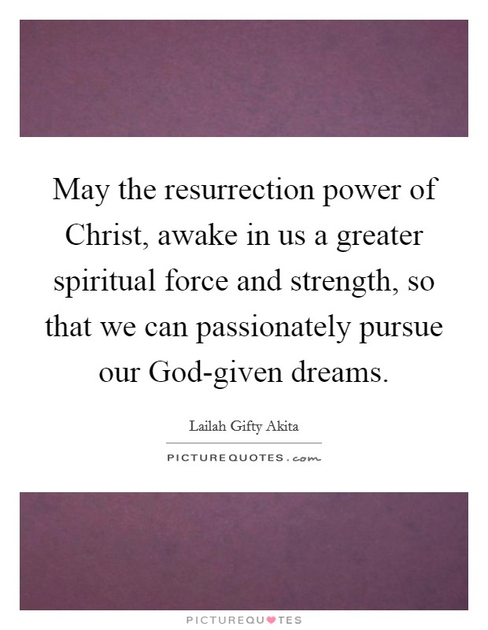
“The difference between knowing Christ and knowing the power of his resurrection,” says Keller, “is the difference between knowing a person and resembling a person . . . It is not about relationship but about supernatural character growth. When Paul says, “I want to know him,” it means, “I want to be with him,” but when he says, “I want to know the power of his resurrection,” it means, “I want to be just like him.” Look at the deadness in your life. Look at the anger. How is that going to be turned into forgiveness? Look at the insecurity. How is that going to be turned into confidence? Look at the self-centeredness. How is that going to be turned into compassion and generosity? How? The answer is that the dead stuff gets taken over by the Spirit of God . . . The minute you decide to receive Jesus as Saviour and Lord, the power of the Holy Spirit comes into your life. It’s the power of the resurrection—the same thing that raised Jesus from the dead.” – Tim Keller

