St. Margaret’s Community Church of Scotland Dunfermline
38 Garvock Hill, KY12 7UU
Iain Greenshields, Tel: 07427477575
Email: revimaclg@hotmail.co.uk

4th April 2021 Newsletter
Last year at this time we were entering Easter not fully understanding what we were facing and the year that was going to lie ahead of us – perhaps that is just as well! We have had to face up to the fact of how fragile our world can be.
Easter teaches us to prepare ourselves for the unexpected and to fully integrate it into our lives.
He is being treated like a criminal – hardly the qualifications one would expect for the Saviour! All of these accusations being hurled at Him might have led people to the conclusion that” there is no smoke without fire” and perhaps Jesus is not all that He appeared to be.
“Guilty!” That is the verdict that we hear from Pilate. Well, not quite. In fact, Pilate says that he could find no reason to condemn Jesus. But Pilate was either weak or a shrewd political manipulator because he realised that there was only one way to stop a riot and appease the crowd – after all, it was only the life of a common man from Galilee!
Off He goes to the Cross, His life covered now in failure – this is the end of the great adventure. But things are not always what they seem to be. On that Cross something remarkable took place. The not guilty took the place of the guilty and effectively died for the sins and guilt of the world – there is a reflection of John 3:16 – “For God so loved the world He gave His only Son that whoever believed in Him would not perish but have eternal life.” That truth screams from the Cross as the guiltless One takes the place and the punishment of the guilty.
Here, and only here, are sinners made right with God. Here and only here, is forgiveness to be found – things are simply not what they appear to be on the surface.
And so, it ends! He is dead, in a tomb and His mother and followers grieve. But His followers go to the tomb.
Women go to the tomb to anoint His body and He is not there.
Mary Magdalene is there, and she meets Him and realises that something remarkable has happened – that He is risen. She does not recognise Him at first because His body has been transformed.
Peter and John rush to the tomb – everything there is orderly, but Jesus is not there.
Then Jesus appears, time and time again to His followers over a period of 40 days – He is indeed risen. Death has been overcome – this is not the end of the story but a dawning of a new day – the Kingdom has Come!
Sin, paid for, guilt removed, death defeated. It hardly seemed possible, but all of this is accomplished. As the story unfolds, Good News fills the veins of His followers. They are no longer fearful – they are bold. The unimaginable has happened.
Easter is here to remind us of the incredible, life changing events, that occurred. We are called to believe, to trust, to follow, to be inspired, to declare to the world the good news born out of what seemed impossible. Iain
Intimations
Services will be at the normal times on Sunday – Facebook will go on at 9am, Zoom at 9.45am.
Easter Services:
1st April Maundy Thursday Communion Service in the Church at 7pm.
2nd April Good Friday Zoom Service at 3pm [significance of 3pm is this is the time Jesus died].
4th April Easter Sunday – Facebook 9am, Zoom 9.45 and 11.00am in the Church. For Livestream go to YouTube and in the search put in Dunfermline St. Margaret’s Church of Scotland.

Please contact Irene Cunningham and let her know if you plan on being at the church service – 01383731947

Lily Millar funeral will take place in the Church on Thursday 1st April at 2pm – it is hoped that the Service will be livestreamed from the church – go to YouTube and in the search put in Dunfermline St. Margaret’s Church of Scotland.

HYMN VERSES
Our chosen verse for this week comes from four of our members and again, they have remarkably chosen the same verse – it is 392 in the latest edition of the Church Hymnary – When I Survey the Wondrous Cross, verse 4.
Were the whole realm of nature mine,
That were an offering far too small,
Love so amazing, so divine,
Demands my soul, my life, my all
To sum up the essence of what all of the different people said, this hymn sums Easter up perfectly.
[If you have a verse from a hymn you would like to offer – even anonymously – just drop me a note or an email.]
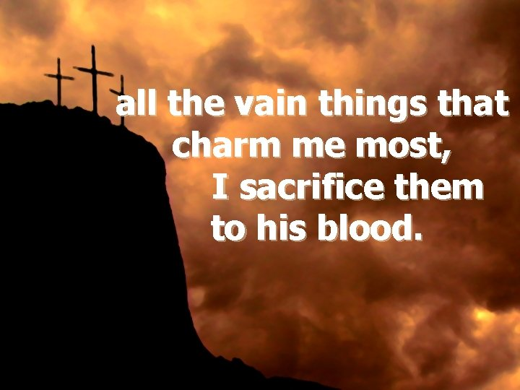

“Our tendency in the midst of suffering is to turn on God. To get angry and bitter and shake our fist at the sky and say, "God, you don't know what it's like! You don't understand! You have no idea what I'm going through. You don't have a clue how much this hurts."
The cross is God's way of taking away all of our accusations, excuses, and arguments.
The cross is God taking on flesh and blood and saying, "Me too.”
― Rob Bell

