St. Margaret’s Community Church of Scotland Dunfermline
38 Garvock Hill, KY12 7UU
Iain Greenshields, Tel: 07427477575
Email: revimaclg@hotmail.co.uk

21st February 2021 Newsletter
A survey was carried out just before the pandemic – an extensive survey that asked a cross section of people in society what were the words that they most liked to hear:
- First choice was, “I love you.”
- Second choice was, “I forgive you.”
- Third choice was, “Dinner is ready!”
Would these have been your choices? To be honest, I think they might just be mine! Why then is it that these three things are considered by so many people to be so important?
Be honest, to hear those words, “I love you” spoken and to know that the person speaking them, means what they are saying; is that not the most wonderful gift? Can we hear anything more important? How does it make us feel?
Perhaps these words come from a parent, simply to remind us of how much we matter to them – how deep the relationship goes! Maybe they are words that come from our spouse or a brother or sister! Whoever they come from the intention behind them is designed to ensure that we know how special we are to that other person. It is a statement of more than just affection – it goes deeper than that; much deeper.
But what if these words come from a Divine source? What if these are the words of God Himself, spoken in human language by his greatest emissary – Jesus Christ, God the Son whose principal reason in coming was to communicate that we are loved before time, in time and beyond time [the Bible describes this as “eternal” love]?
Then, there is “I forgive you!” Are you like me? Do you mess things up – often? When you do mess things up and often hurt people, do you not long to hear those words, “I forgive you?” We may not feel as if we deserve it sometimes, but what a difference when we hear them!
The flip side of course is when we say the same words ourselves and how healing that can sound to another person! How healing too, it can sound when we speak these words to ourselves!
But when God speaks these words to us! When we hear Jesus telling us that he came to die for us so that we might be forgiven – is that not the best news we can hear? Is it not mesmerising for us to know that God is prepared to wipe the slate clean and all that we need to do is to ask for forgiveness and it will never be withheld?
No wonder the first two are so important; indeed at the top of the list! But the third, “Dinner is ready!” Really?
If you are like me and you enjoy your food, you will immediately understand why it is in the first three. Dinner is ready, means that there is someone to share food and time with. Is that not what we miss when we lose someone, or a child leaves home? How special it is to share time and space with others over food – we should never swap, sitting with a tray in front of the TV when there is someone we can share time and food with – such a gift!
Iain
Intimations
Services will be at the normal times on Sunday – Facebook will go on at 9am, Zoom at 9.45.
Zoom Service on Wednesday at 6.45 beginning at 7.00pm. This is the beginning of the Season of Lent and we will be treated to a series of reflections by Con Campbell on the life of Peter with the filming shot in situ.
At Easter I am planning to send round an Easter Card from the Church to at least 500 homes and would love to put a knitted cross in each envelope – pattern can be got from Irene on 01383731947 ireneandjim@gmail.com or June on 01383724992 junemaco@gmail.com.

HYMN VERSES
Our chosen verse for this week comes from Ian Carlton, a retired elder. Ian is now only a few short months away from his 100th birthday!
Our verse comes from the hymn “Mine eyes have seen the glory” which is number 476 and verse 4 in the Church Hymnary:
In the beauty of the lilies Christ was born across the sea,
With a glory in His bosom that transfigures you and me;
As He died to make men holy, let us die to make men free!
While God is marching on.
Glory! Glory! Hallelujah!
Glory! Glory! Hallelujah!
Glory! Glory! Hallelujah!
His truth is marching on.
“Among other things Ian remembers this hymn and its tune being played by the brass bands on old gala days in Dunfermline as the children processed down to the Glen!”
[If you have a verse from a hymn you would like to offer – even anonymously – just drop me a note or an email.]
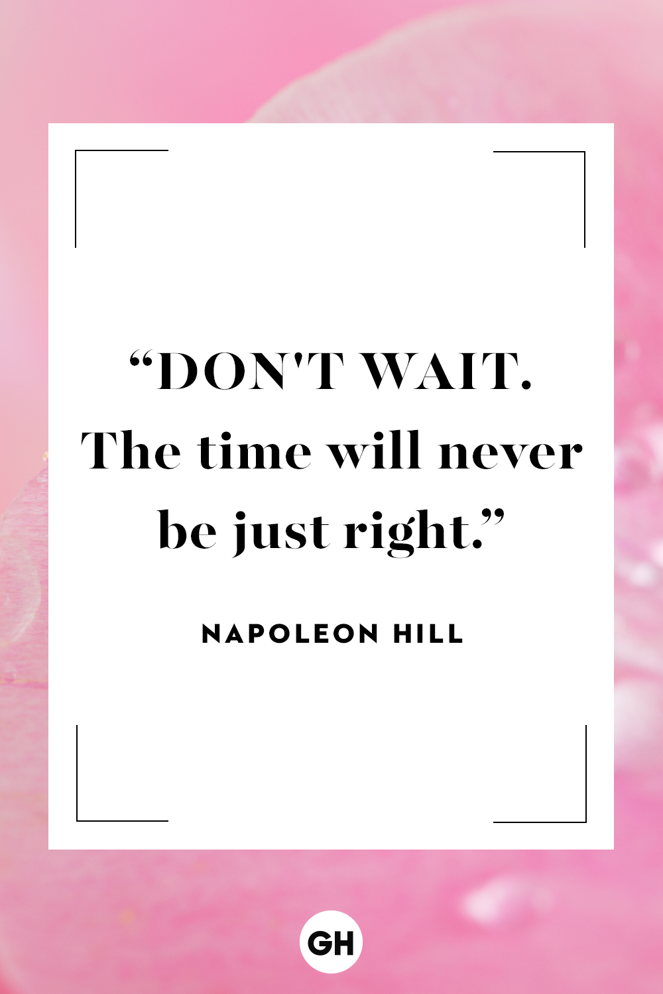

“Not everything that is faced can be changed, but nothing can be changed until it is faced..”– James Baldwin

“I’ve got all the money I’ll ever need, if I die by four o’clock.”– Henny Youngman

“Here’s something to think about: How come you never see a headline like ‘Psychic Wins Lottery’?”– Jay Leno

“Everything that used to be a sin is now a disease.”– Bill Maher

