St. Margaret’s Community Church of Scotland Dunfermline
38 Garvock Hill, KY12 7UU
Iain Greenshields, Tel: 07427477575
Email: revimaclg@hotmail.co.uk

28th February 2021 Newsletter
Brennan Manning a former Catholic priest and now evangelist of some note and reputation, usually begins his talks slowly and very deliberately until he grasps the grace of God and then flows like this in his speaking:
“Why is Brennan Manning lovable in the eyes of God? Because on February 8th of 1956, in a shattering, life-changing experience, I committed my life to Jesus. Does God love me because ever since I was ordained a priest in 1963, I roamed the country and lately all over the world proclaiming the Good News of the gospel of grace? Does God love me because I tithe to the poor? Does he love me because back in New Orleans I work on skid row with alcoholics, addicts, and those who suffer with AIDS? Does God love me because I spend two hours every day in prayer? If I believe that stuff I’m a Pharisee! Then I feel I’m entitled to be comfortably close to Christ because of my good works. The gospel of grace says, “Brennan, you’re lovable for one reason only — ​because God loves you. Period.”
Why return so often to “grace?” Because it lies at the heart of the Gospel and our own identity. The Christian is surely someone whose life has been captivated by the Gospel. What do I mean by that? We have been “caught” by the Good News of Jesus. We have come to realise that all of our hopes and aspirations are to be found in him and in relation to Him we find through faith all that we need in this life and next.
I had a very perplexing conversation recently with a group of Church people – not from St. Margaret’s, I hasten to add – that left me wondering if most of them had even the remotest clue what the Christian faith is all about?
Surely at the heart of it is Jesus himself! One cannot separate Jesus from his teaching – surely that is obvious and that what is radical about following Jesus is for us to follow in His footsteps even if and when that means we go against the trends and flow of current cultural norms?
Neither can we separate Jesus from what He fundamentally did in order to save us? Coming to Jesus means that we acknowledge our great need of forgiveness and that that was fully met when He died for our sins on the Cross. We come to Him acknowledging our need of His grace which can only be found in the Cross – there is no other way.
And the Resurrection? Was that not the final, glorious point at which everything was complete? Death is vanquished and there lies our hope.
So, was Brennan Manning right? Grace tells us that we are loved not for anything we have done or will ever do but for all that Jesus has done for us! That’s the Gospel – that is the Good News in a nutshell.
Where does this take us? Surely we need to come out of this lockdown with a keen enthusiasm to grow our Church through a positive presentation of the Gospel to those around us? Simply put, if we stand still, we die and have no future. Positively put, God can work powerfully through us if we are willing to put our faith in His power and the Gospel of His Son.
Iain
Intimations
Services will be at the normal times on Sunday – Facebook will go on at 9am, Zoom at 9.45.
Zoom Service on Wednesday at 6.45 beginning at 7.00pm. This is the beginning of the Season of Lent and we will be treated to a series of reflections by Con Campbell on the life of Peter with the filming shot in situ.
At Easter I am planning to send round an Easter Card from the Church to at least 500 homes and would love to put a knitted cross in each envelope – pattern can be got from Irene on 01383731947 ireneandjim@gmail.com or June on 01383724992 junemaco@gmail.com.

HYMN VERSES
Our chosen verse for this week comes from one of our members who describes herself as being on the journey of faith for a long time!
Our verse comes from the hymn “The King of Love my Shepherd is” which is number 462 and verse 6 in the Church Hymnary:
“And so through all the length of days
Thy goodness faileth never;
Good Shepherd, may I sing thy praise
Within thy house for ever!”
“I have always loved this hymn and did not for a long time realise that it was a paraphrase of Psalm 23. I find the words inspiring and full of hope.”
[If you have a verse from a hymn you would like to offer – even anonymously – just drop me a note or an email.]
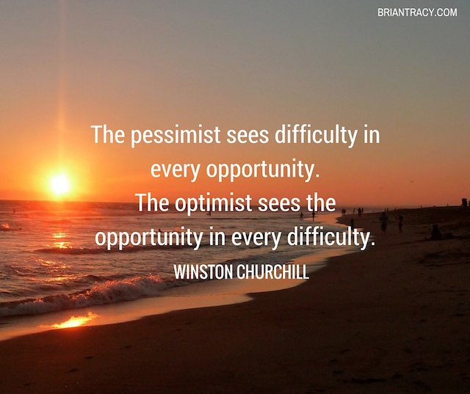

“ Strive not to be a success, but rather to be of value.” –Albert Einstein

“Life is 10% what happens to me and 90% of how I react to it.” –Charles Swindoll

“I am not a product of my circumstances. I am a product of my decisions. –Stephen Covey

“I’ve learned that people will forget what you said, people will forget what you did, but people will never forget how you made them feel.” –Maya Angelou

