St. Margaret’s Community Church of Scotland Dunfermline
38 Garvock Hill, KY12 7UU
Iain Greenshields, Tel: 07427477575
Email: revimaclg@hotmail.co.uk

14th March 2021 Newsletter”
In the Middle Ages the Church produced a list which it referred to as the seven deadly sins. Can you recite them? Here they are:
- pride,
- greed,
- wrath,
- envy,
- lust,
- gluttony,
- sloth.
Why are they considered “deadly?” Surely it is because of the effect that they have both on society and on relationships! Where any of these “sins” exist, they diminish both the person who exercises them and the recipients of them. I know that it is not fashionable to speaks of sin or sins anymore, but surely it makes sense to us as Christians.
It will do us no harm to look at that list and to examine ourselves in the light of these sins in order that we might dismiss them and their effects from our lives.
However, as a counter-balance to the seven deadly sins, the Church in the Middle Ages came up with what it called seven works of mercy. They are:
- Feed the hungry,
- Give drink to the thirsty,
- Clothe the naked,
- House the homeless,
- Visit the sick,
- Ransom the captive,
- Bury the dead.
In other words, it is not enough simply to get wrong things out of our lives, but with God’s help, replace them with positive, good and helpful works. That makes sense does it not – goodness is not simply the absence of badness in our lives but the evidence of positive and helpful virtues.
Later, the Church added a supplemental list of spiritual works of mercy. They are:
- Teach the ignorant,
- Counsel the doubtful,
- Admonish sinners,
- Bear wrongs patiently,
- Forgive offences willingly,
- Comfort the afflicted,
- Pray for others.
The language in all of these lists may be out of date but surely the sentiments are not? If we are to make an impact on our own personal lives, out must go what is negative and in, what is positive. If we are to make an impact on our world around us and in the lives of the people we know, the same principle applies.
I feel that we are living in times that are crying out for a new, authentic way of living – a new direction with a definite and positive alternative to the shallow and selfish way that our society has been travelling for such a long time. So, look at the lists – bring them up to date, if you will and let’s work our way forward into a new way of being and doing. Iain
Intimations
Services will be at the normal times on Sunday – Facebook will go on at 9am, Zoom at 9.45.
Zoom Service on Wednesday at 6.45 beginning at 7.00pm. We are continuing this Season of Lent with reflections by Con Campbell on the life of Peter with the filming shot in situ – this is number 4 in the series.
Tom McIntosh is recovering from surgery and is anxious that the church garden is not neglected. The Garden is one of the features that speaks positively to our community and we could do with a pool of volunteers to keep things ticking over – contact Tom on 01383 726342

HYMN VERSES
Our chosen verse for this week comes from more than one of our members and indeed was a favourite of our late Lily Miller – it is 220 in the latest edition of the Church Hymnary – The day you gave us Lord is ended. Curiously, the same verse was chosen by all three people – verse 3:
As o’er each continent and island
The dawn leads on another day,
The voice of prayer is never silent,
Nor dies the song of praise away.
The reasons for the choice of this verse were different but the theme of prayer was in each one of them. It is comforting to know that through every 24 hours, in every country and time-zone, people are praying.
[If you have a verse from a hymn you would like to offer – even anonymously – just drop me a note or an email.]
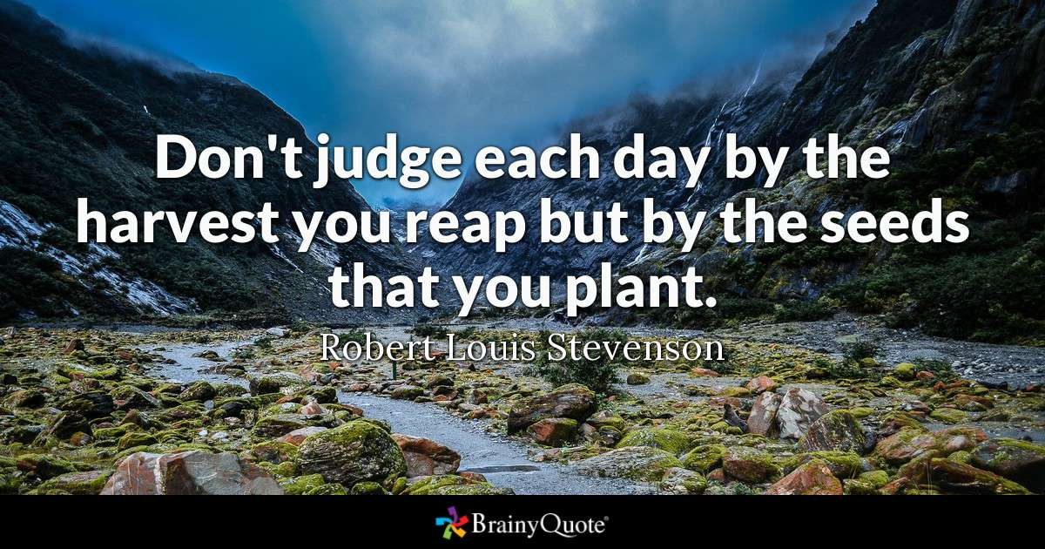

Everything you’ve ever wanted is on the other side of fear. –George Addair
“A person who never made a mistake never tried anything new. – Albert Einstein
When one door of happiness closes, another opens, but often we look so long at the closed door that we do not see the one that has been opened for us. –Helen Keller
“How wonderful it is that nobody need wait a single moment before starting to improve the world. –Anne Frank
The battles that count aren't the ones for gold medals. The struggles within yourself--the invisible battles inside all of us--that's where it's at. –Jesse Owens

