St. Margaret’s Community Church of Scotland Dunfermline
38 Garvock Hill, KY12 7UU
Iain Greenshields, Tel: 07427477575
Email: revimaclg@hotmail.co.uk

21st March 2021 Newsletter
C.S. Lewis has a very vivid illustration in his book called “The Great Divorce.”
He imagines a bus trip of passengers who have come from hell to visit heaven. They are pale, insipid figures.
In terms of Lewis’ thinking they have become what they always were – empty, light – without the glory of their being.
Lewis’s guide and interpreter in this story is George MacDonald, the Scottish writer whose work had such a great impact on Lewis and his imaginative powers.
[George MacDonald (10 December 1824 – 18 September 1905) was a Scottish author, poet and Christian minister. He was a pioneering figure in the field of modern fantasy literature and the mentor of fellow writer Lewis Carroll. In addition to his fairy tales, MacDonald wrote several works of Christian theology, including several collections of sermons.]
At one point in the story, they see an insubstantial, ghost-like figure, with a little red lizard on his shoulder. The red lizard is constantly talking, dominating his life.
An angelic figure offers to deliver and save the ghost by killing the lizard. As the angel comes closer the ghost shouts out, “Stop, you might hurt me.”
The angel says, “I didn’t say it wouldn’t hurt; I said that I would kill the lizard.” The ghostly figure has a deep fear – kill the lizard and the angel might kill him!
Eventually, after much debate, the angel kills the lizard. The ghost suddenly becomes substantial – real, we might say – and is completely transformed.
What was the point of the story?
We are in the season of Lent leading up to Easter. Jesus said the following:
“Anyone who wants to follow me must take up their cross, deny self and follow me.”
Paul in Galatians said,
“I will only ever boast in the cross of our Lord Jesus Christ, by which the world has been crucified to me and I to the world.”
Finally, Paul says in First Corinthians,
“I know very well how foolish the message of the cross sounds to those who are on the road to destruction. But we who are being saved recognise this message as the very power of God.”
The lizard that was slain on the man’s shoulder was his old life. Our new life happens when we focus on the Cross and the new life of Jesus takes over from the old, past life, lived for ourselves.
Taking up the Cross means to change the focus of our lives and identify fully with Jesus. The next step is to “deny self” – this means that we no longer put ourselves and our will first but Jesus and His will – if we are not willing to do this then we cannot be or call ourselves a Christian!
So, do we let the lizard go for the Cross and in so doing begin life with Jesus? The choice is ours.
Iain

Intimations
Services will be at the normal times on Sunday – Facebook will go on at 9am, Zoom at 9.45.
Zoom Service on Wednesday at 6.45 beginning at 7.00pm. We are continuing this Season of Lent with reflections by Con Campbell on the life of Peter with the filming shot in situ – this is number 5 in the series.
Tom McIntosh is recovering from surgery and is anxious that the church garden is not neglected. The Garden is one of the features that speaks positively to our community and we could do with a pool of volunteers to keep things ticking over – contact Tom on 01383 726342

HYMN VERSES
Our chosen verse for this week comes is 380, There is a Green Hill far away, in the latest edition of the Church Hymnary – The chosen verse is verse 5 [It is amazing how many people choose the final verse pf a hymn]:
Oh, dearly, dearly has he loved,
And we must love him too,
And trust in his redeeming blood,
And try his works to do.
I remember singing this in both Sunday School, primary and high school, always at Easter time. I love the simplicity and beautiful sentiments that are expressed in the hymn and it always warms my heart to sing them.
[If you have a verse from a hymn you would like to offer – even anonymously – just drop me a note or an email.]
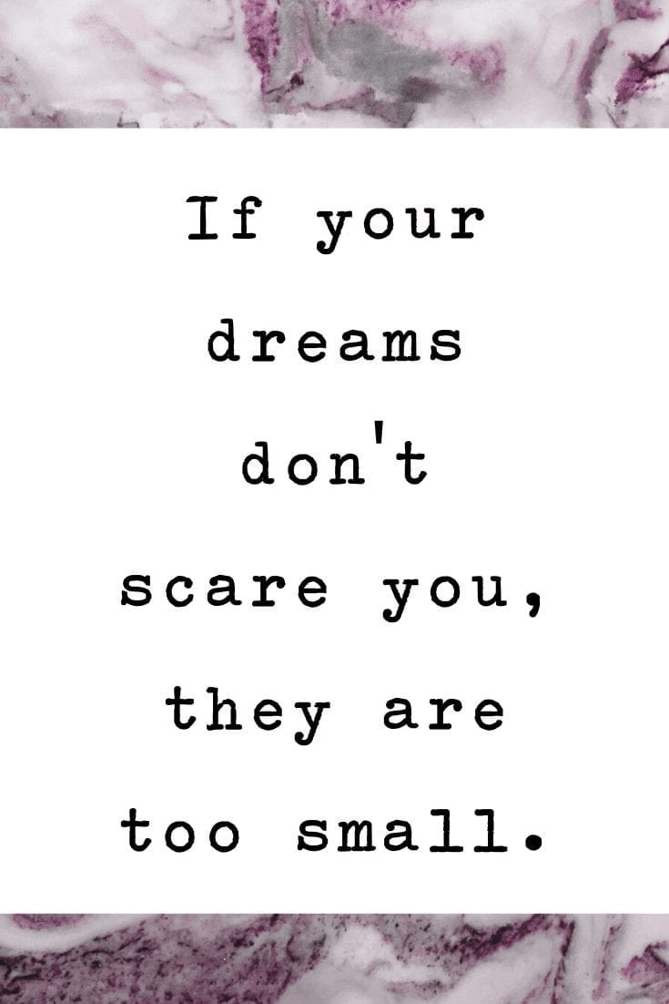

Change your thoughts and you change your world. –Norman Vincent Peale

It’s not the years in your life that count. It’s the life in your years. –Abraham Lincoln

Our lives begin to end the day we become silent about things that matter. –Martin Luther King Jr.

Remember that not getting what you want is sometimes a wonderful stroke of luck. –Dalai Lama

